The Ni-Wumpf
System 80
Programming Manual

Copyright 2007 Ni-Wumpf Ltd.

Revision B

1 Overview 3
2 The Pinball Coding Architecture 4
2.1 Where to begin 4
2.2 The Coding Process 5
2.3 Logic in Layers 5
3 Platform Design 6
3.1 Designing the Hardware Constraints 6
3.1.1 Displays 6
3.1.2 Switches 7
3.1.3 Lamps 8
3.1.4 Solenoids 9
3.1.5 Sounds 10
3.2 Adding the Software Routines 13
3.2.1 Hardware API Hook Routines 14
3.2.2 Hardware API Routines Available 14
3.2.3 Common Platform Hook Routines 14
3.3 Platform Design Coding 14
4 Variables 16
5 Timers 18
5.1 Adding a New Timer 19
6 Menu Commands 20
7 Command Syntax 21
7.1 The process of entering a command 21
7.1.1 Editing Command Lines 21
7.2 Programming commands 21
7.2.1 assign 21
7.2.2 call 23
7.2.3 go to 23
7.2.4 if 23
7.2.5 label 24
7.2.6 lamp 24
7.2.7 rem 24
7.2.8 score 25
7.2.9 solenoid 25
7.2.10 sound 25
7.2.11 timer 26
8 General Editing 27
8.1 Renaming entries 27
9 Coding a Game! 28
9.1 Fill in the Preliminaries 28
9.2 Prepare the Game Hardware Components 28
9.2.1 Define Lamp Actuated Solenoids. 28
9.2.2 The Ball Search Hook Routine 29
9.3 Ball Launch sequence. 30
9.4 Program the Outhole routine. 30
9.5 The Attract routine 31
9.6 Drop Target Banks 32
9.7 Cups and Launch Pockets 33
9.8 Manually Overriding the Solenoid Timing Cycle 33
9.9 Extra Ball / Special Logic 34
9.10 Multiball Logic 34
9.11 Adding Entries Into the Game Setup Menu 35
9.12 Acting on the First or “Next” Switch to be Struck 36
10 Programming Components 38
10.1 Platform Variables 38
11 Building the Executable 38
11.1 Troubleshooting the Build 39
11.2 Using the main.map File on the Download Page 40
Appendix A – Hardware API Hook Routines 42
Appendix B – Platform API Routines 43
Appendix C – Platform Hook Routines 45
Appendix D – Gottlieb System 80 Platform Routines 46
Appendix E – Platform NVRAM variables 51
Appendix F – Platform Power-Up Variables 54
Appendix G – Platform Game Variables 57
Appendix H – Platform Ball Variables 58

Overview
It’s interesting to observe the trends demonstrated by a particular cross-section of a multi-cultural group of people. Without working too hard trying to get an idea of why I bring this up, here’s a mental exercise of where this is going - one day somebody invents a new vehicle to address a particular segment of the automotive industry - a demographic cluster desperate to own a station wagon to transport their bourgeois possessions, family and lawn mowers in, but too “hip” to actually own a car that their parents once drove. So once the propaganda campaign is complete to go along with this new vehicle deployment, a billion-billion dollar marketing segment is finally mined successfully by Detroit. And it’s the same old story, of course, perception and posturing can actually breed a market – despite what Harvard Business School may teach you. Our culture is rife with examples of this. …in reality, of course, the SUV market that we’re talking about here, is just a poser of a vehicle that their parent’s-parent’s once drove - but without the wood paneling that makes a “woody” seem pretty cool right about now. …and with much worse gas mileage.
Nonetheless, it’s this same cultural “fad” lifestyle we participate in, and of course, the very transient nature of the human psyche itself, that once fostered a huge following of pinball fanatics in the early 1990’s. People who suddenly realized that those 300 lb. devices commonly discarded by vending operators as if they were last years issue of “Playboy”, were now suddenly a rare commodity to collect and restore. Everyone should now have a gameroom - and the game in that room should be a pinball game or a video game, and possibly a pool table. And a lot of people got involved in this fad, and amongst them, some serious fanatics - a hard-core subset of which went about un-raveling the coding mysteries of the 1980’s arcade industry. An industry that produced such fantastic inventions such as “Black Hole”, “Fathom”, “Pacman”, and digital watches. And it was this group that once convinced me that, given the proper set of tools, these guys could tweak a Woody that would roll straight over a Hummer. Heck, if you can make a Pacman board do the things I’ve seen it do to the game, you too would be wondering just how far pinball enthusiasts could go. And that’s how we all got here …and now.
So you want to program a pinball machine…
Well, it’s not that hard. You’re now only limited by your imagination, the physical layout of the game you’re programming, and possibly the cost of buying and routing a whitewood prototype into something the world has never seen before. But that’s a manual of a different color. In this one, you’ll get the description of how to program a game, the basics of hardware I/O, the tools of logic that allow the simple event of a pinball striking a target to create a sequence of related events, and the examples to demonstrate each facet of programming logic.
…and with that, it’s time to get serious.

The Pinball Coding Architecture
The integrated development environment (IDE) described here is a web-based programming tool used to program pinball game logic - there is no software to download - no disks to install. The process works by using a web-browser on a computer at the client side, (you, the programmer), and a server at Ni-Wumpf’s facilities. The user creates code that is stored in XML format locally on his computer (all games created by the IDE are kept locally), and then uploading these files to the Ni-Wumpf server for interpretation, compilation, and eventually, download back down to the client. Once the client retrieves the binary image it is subsequently uploaded to the Ni-Wumpf CPU for testing and operation. The whole process of taking your coding ideas, and getting that idea onto a piece of hardware that controls bumpers, displays, and sounds can take as little as three minutes to pull off.

Where to begin
When starting this process of writing a game, the user is invited to visit the Ni-Wumpf website to download the development environment by accessing; www.ni-wumpf.com/IDE via their web browser. Once the site has been accessed, your browser will do one of two things – it will attempt to install the Java runtime environment in your browser, or it will use the already installed plug-in and immediately begin downloading the applet from our website.
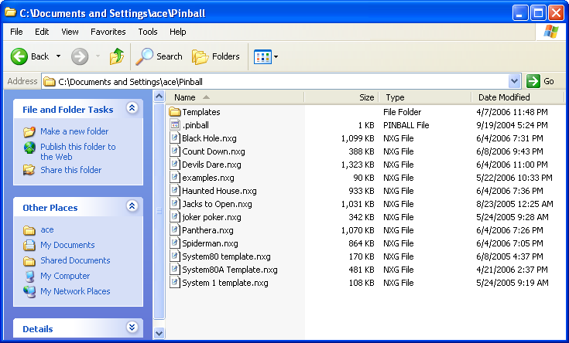 Figure 1 – Pinball Directory Structure
Yes, the IDE is an applet, and yes, Java is piggishly slow. Them’s the breaks – so don’t run off too soon after starting to load the applet, it just takes some time to load. However, be aware, that prior to running this IDE, the user should first prepare the client environment for development by following a few steps here first. You’ll need to download the pre-defined platform layers and definitions that make up a lot of the coding routines to be used in programming your new game. Get the “ubq.zip” file from the www.ni-wumpf.com/ubq/source page by clicking on the link there. This will prompt you to save this file somewhere on your disk. Once that is complete, unzip the contents of this zip file, and put them in your home directory. For windows users, this is not your “My Documents” directory, but the directory immediately above this (i.e. c:\Documents and Settings\ace for me). When you unzip the file, be sure to keep the directory structure in the zip file intact on your system. Once completed, you’ll wind up with a c:\Documents and Settings\ace\pinball directory to store your pinball programming files in, and a c:\Documents and Settings\ace\pinball\templates directory for the platform files (see above). You can poke around these files if you’re inclined to, but be aware that they are XML files – and the syntax is a bit lengthy.
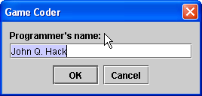
Now like any programming environment, the user is going to be working with a programming language; with variables; and the ability to call one set of instructions from the next (subroutines). However, because the objective is solely focused on the control of a simple pinball machine, the complexity of programming can be greatly simplified to the user. Variables are easily defined, and instantly available for use in easy-to-use command menus. Typographical errors are nearly non-existent, and the syntax is handled by the IDE.
OK, now open the IDE. The first step in the process as the applet begins, is to register your name with the system. This step is important - it will establish the name used on the Ni-Wumpf website to access the files subsequently compiled by the system. Once this is completed, you’re left with a pretty sparsely populated window with but a few menu items to begin the process with.

The Coding Process
Now that the basics are in place to begin coding with, the overall process of; code, upload / compile to the website, download to the client, program the board, and test can be reviewed. First, be aware of the client / server separation in your development environment. Your computer is the client when dealing with the Ni-Wumpf webserver, however, you only need to keep a connection to the site when you attempt to download the Java applet (when first accessing the site), when uploading your XML file to the server for compilation, and when downloading the binary image that this generates. All of the process of programming, saving and restoring your program files is performed locally without network support. Similarly, the task of re-programming your Ni-Wumpf CPU is done locally as well.

Logic in Layers
Without knowing what it takes to program a game, it must seem a pretty daunting task at first blush. When you think about it, there must be a lot of programming involved in order to recognize that a pinball has struck a target, that the player should get 500 points for the event, to add that value to his score, to display that new value in the displays, and to remember that this target has been hit sometime in the future.
Well, yes, and no.
The first part of recognizing the switch to be struck is nothing more than entering a value in a table of switches for the game, and the latter part is largely accomplished with the line; “score 500”. Viola! That’s done – no joking. What’s left unsaid here is the amount of code behind the statement “score 500”. And it is a lot. But nothing that you, the programmer, need to know that much about. The way this is done is to code in “layers” of pinball logic. A layer is like an orange, you peel it, and there is a lot of fruit underneath, but from the outside, there’s just the peel, inside is the fruit, and inside that is the seeds. Not a great simile, I know – but who knows where the reader is coming from.
Now, using the Ni-Wumpf IDE, the user is normally working at the programming layer. This layer is what this manual addresses. There is a layer directly beneath this called the “platform” layer, and this is the set of routines that pertain specifically to the type of game being programmed, be it a Gottlieb System 1 game, a System 80 game, or a Bally system 35 game. The manual will also touch upon this layer. Beneath that is the hardware layer, the layer that interfaces the Ni-Wumpf CPU to the game hardware itself. And finally, beneath that is the firmware layer, the code that resides in the chips used in the hardware. We’re not going there here.
To back up just a bit, it is important to note that the IDE has two modes of programming, one that deals with how to write game logic – the game coding mode. And one by which the programmer may actually code the platform layer – platform coding mode. For the most part, Ni-Wumpf will be writing the platform layer, but it is important to note that the user is fully able to create a platform coding layer – or to modify the ones provided by Ni-Wumpf.

Platform Design
The IDE was written for flexibility – to be able to support and program logic on game architectures that may yet be addressed in hardware. In order to do that, it is necessary to allow the software designer the ability to define the constraints and I/O capabilities of the game hardware for which games will be written. This platform definition creates an independent program file that will later be used when writing games in order to both build on the software routines created in the platform design, and to constrain the limits of I/O capabilities, such as how many solenoids there are, how many lamps and sounds, etc..
In the course of writing a game, the first step is to identify the hardware platform to be used. Platforms are the family of game hardware that the game is part of, for example Eight Bally deluxe is a Bally system 35 platform. The platform name normally relates to the type of CPU used by all of the games in the family, and in most cases will be a superset of several earlier CPU designs. For example there is no reason to design an MPU-17 style Bally platform when the MPU-35 architecture supersedes that older CPU. Likewise a Williams System 7 design is the architecture that handles the System 3, 5, and 6 model CPU’s.
In addition to defining and constraining the hardware characteristics of the game platform being designed, the platform file also defines a set of routines common to all games of this platform. Routines such as ending the ball in play when the ball hits the outhole, scoring a free ball, what the game does in idle mode, or in between balls, how to perform hardware testing, what operations are performed at the start of the game, etc.. After the hardware constraints are defined, the naming conventions can be used in the platform routines being written. See the section below for a complete review of platform routines, and the hardware API routines included.

Designing the Hardware Constraints
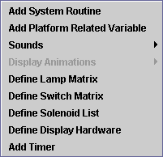
Putting aside the logical portion of the platform design such as the actual programming, using variables, and scheduling asynchronous event handling, there are five basic I/O areas common to all pinball machines that are defined in platform creation; displays, lamps, solenoids, switches and sounds. The Hardware Components menu pictured to the right show each of the logical functions used in a pinball machine as well as several other areas only yet envisioned for expansion, such as a multi-voiced sound card, and the capability to interface with a dot-matrix display controller. These interface definitions have not yet been created for these I/O channels.
Each of the menu entries shown to the right opens a dialog box for overall boundary definition, such as how many switches there are, and how they are configured by strobe and return lines. Once the boundary limits have been defined, a table is instantiated that represents the platform I/O. In most cases, this table will be a logical representation of some of the tables found in the games manual, such as the switch matrix, or the list of solenoids.

Displays
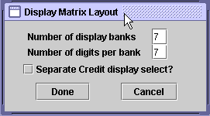
“Define Display Hardware” - Normally a game will output display data in a matrix format similar to a switch matrix. In other words, the CPU doesn’t normally pump out the numbers to the displays continuously – that would take a lot of wiring: eight wires (one for each segment in a digit) multiplied by the number of digits in the displays (in the System 1 game that minimum number of digits is 28 digits). The total cable thickness of this amount of wiring (over 200 individual wires) from the CPU to the displays would make it pretty hard to open the head! So, the displays are multiplexed and the data strobed continuously to make the displays look as if they are continuously lit. In this way, the display digits are cyclically scanned in order with the output value for each “bank” (of eight bits of segment data) filling in that digit for the bank. For example, in the Gottlieb system 1 platform, there are only two banks; “A” and “B”, comprised of 16 digits each. The player one display is actually the first six digits of the first bank – player two, are digits 7 through 12. Lastly the credit display comprises digits 13 through 16. So when designing the System 1 platform, the information provided into the Display matrix definition menu would be; 2 for the display banks, and 16 for the number of digits per bank – there is no separate credit display select line.
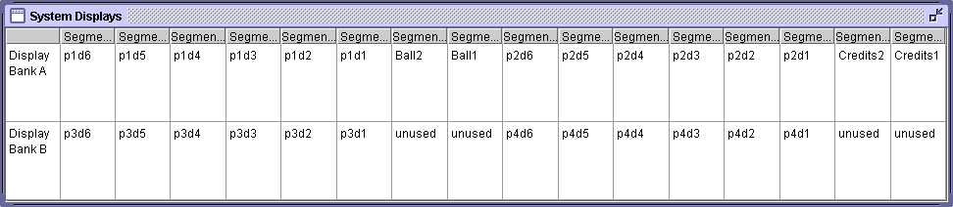
Once the form has been filled out and submitted, the IDE will request the number of players that the platform will support, and then finally, a table is created based on the input provided. The number of players that the game can handle will be used later during programming. Like all of the tables being created in this way, the purpose of the display form is to name the digits in such a fashion that they can be easily identified and used in the programming phase; like “player1digit1” or “p1d1” for short. As in all tables defined in the IDE, each cell of the matrix is an editable field, the text labeling the switch is simply entered into the cell field corresponding to the switch number.

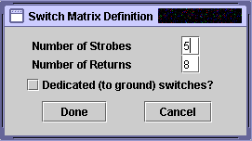
Switches
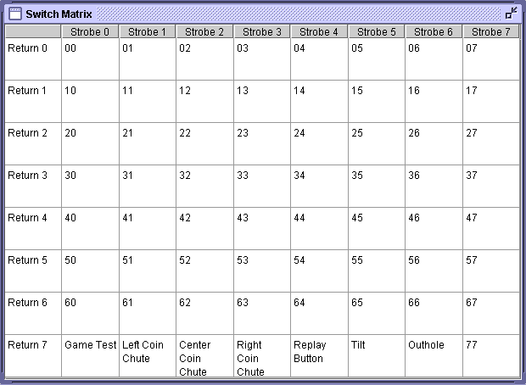
“Define Switch Matrix”- all games operate using an input matrix of contacts to detect playfield switches, where across one return line a number of switches are connected simultaneously. Each of these switches is also connected to an independent strobe line. In this way the matrix is formed. The CPU looks at the value of the return line at the exact same time that each of these strobe signals is activated. So, while half of the switches on the return line may be open, and half closed at the same time, the CPU is able to identify which ones are open and which closed, by sampling the return line during each of the active strobe outputs. A switch is then identified as being the combination of what strobe and return line is connected to each end of it. I.e switch “73” is the switch connected to strobe line 7 and return line 3. The CPU core architecture is capable of an enormous switch matrix size - 16 strobes and 14 return lines. Most games do not use more than 8 x 8 switch matrices. The last field in this definition form pertains to hardware circuitry used on the original platform - dedicated switches that are not part of the strobe matrix, switches that are driven directly to ground. Ni-Wumpf logic simulates this functionality by assigning these switches to an additional strobe line, and linking the return lines (to ground) to signal the CPU only while this strobe line is active.
Once the number of strobes and returns used by a platform are entered into the form above, a form something like the one shown below will be displayed. At the platform level, there may be switches in this matrix that are common to all games within the platform. For example, on the Gottlieb System 80 platform, switch number 70 (return - 7 / strobe - 0) always corresponds to the Game Test switch; switch #71, to the Left Coin chute, etc.. In these cases it is appropriate to define these switches within the switch matrix at the platform level. As in all tables defined in the IDE, each cell of the matrix is an editable field, the text labeling the switch is simply entered into the cell field corresponding to the switch number.

Lamps
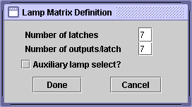
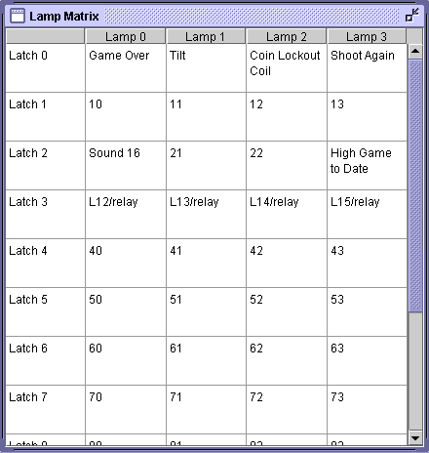
“Define Lamp Matrix” - lamps are arranged in a matrix for a whole different reason than scanning or refreshing – usually this matrix is based on the logic components of the circuitry in the lamp driver board. On the System 80 platform, all of the lamp data is stored on individually addressable latches that are physically 4 bits wide (non multiplexed), therefore the lamp data width (number of outputs per latch) is four. There are also 12 separate latches on the driver board, making the lamp matrix 12 x 4 for this hardware.
On the Bally platform this lamp circuitry is actually expanded through a board select line making the platform capable of supporting two separate lamp driver boards. For this reason, the table can be expanded by selecting the “Auxiliary lamp select” button. When selected, the matrix table is doubled, with the first half of the table corresponding to the first lamp driver boarr, and the second half, to the second board.
Like the switch matrix described above, there will be some latches that will be consistent throughout all of the games in the platform, and can be labeled as part of the platform definition. For example, the high score to date lamp will be consistent across this platform (and nearly all others), the game over, tilt, and shoot again lamp will fall into this category as well.

Solenoids
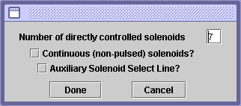
“Define Solenoid List” - the solenoid table is not a matrix at all, but a simple list of the solenoids available to the platform. From the definition menu shown to the right however, the system allows for a separation of solenoids into two columns in the solenoid table (via the “Continuous (non-pulsed) solenoids” checkbox.) The first column represents the default solenoid type that most of us are familiar with - solenoids pulsed and controlled directly by the CPU. All the programmer need do for these solenoids is use the energize solenoid command, and the hardware takes care of how long the solenoid should stay energized, and when to de-energize it. Non-pulsed solenoids are very different outputs that work as toggles to the physical solenoid. A command to energize a solenoid of this type turns it on and leaves it on, while the next call to energize that same solenoid turns it off. In this way the actuation time is controlled directly by the programmer. None of the platforms at this time utilize non-pulsed solenoid circuitry – it is an option for future designs.
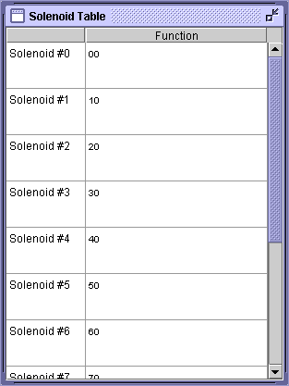
The second check box in the definition window pertains to a separate solenoid select line for an auxiliary solenoid driver board. There were designs in the Bally line as well that called for a second solenoid driver board. However, the base Bally platform architecture does not utilize either the auxiliary lamp driver board, or solenoid board.
As mentioned above, by default, the system controls how long to leave a solenoid on for, and when to turn it off. To do this, there is a programmable variable termed solenoid_pulse_width (described in the section below on platform variables) that defines, in milliseconds, how long the solenoid will be energized for. In this way the software can accommodate different platforms using different types of solenoids that may energize for an arbitrary length of time. It should be noted here, that many different platforms use lamp driver circuitry to control solenoid actuation. In this event, it is up to the programmer to perform this same functionality. An example of how this is done in code is shown below with an excerpt of the routine from Black Hole to pop the ball out of the upper capture hole of the game.
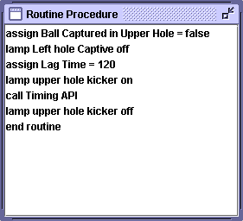
Shown to the right is the code that is executed when the upper hole finally ejects the captured ball. Assorted variables are updated, and a solenoid pulse width of 120 milliseconds is assigned to the Lag Time variable. The lamp that controls the hole solenoid is turned on, and then the blocking subroutine Timing API is called to pause execution of any code for this amount of time. Following this time period the lamp is then turned off, to de-energize the solenoid. The obvious difference between this routine, and a normal solenoid command is the fact that program execution is suspended as the solenoid is controlled in this fashion. With the normal solenoid command, program execution continues immediately after the line of code is executed.

Sounds
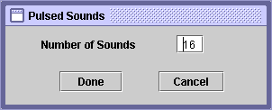
“Sounds” -> “Pulsed Sounds” -> “Define Number of Sounds” – the sounds menu that the System 80 platform can use is buried two layers deep in the hardware definition menu, and can be a bit confusing in navigation. Like the solenoid table above, the sound table is a simple list of sounds that corresponds to the list of sounds that the sound board has available. You wouldn’t know it without first having been challenged by having to code it, but sounds are one of the hardest things to address on the game/platform. The reason for this is simple, the programmer is given a sound board as a resource to use in his game logic - however, there are no tables in any of the manuals that specify what sound corresponds to what signal from the CPU. Without that simple knowledge, it is difficult to build a sound list from which to build your program code from. In other words, the sound board normally operates by playing a sound when a certain bit pattern is sent to it. If the programmer sends it the number “6”, for example, what sound is played? To compound this problem, many sounds created for the original game code are produced by sending the sound board a series of sounds to execute - often, with one sound being played interrupted by the next sound, to create a combination of outputs that sound like a new sound. Rather like taking a rap record, and “skipping” it back and forth over the same track.
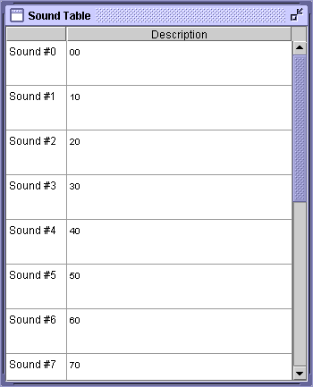
Because of this difficulty, Ni-Wumpf developed a diagnostic tool that plugs into the sound board connector (in place of the sound board) to analyze and report back what signals are being sent to it (figure 2). There is a single 8-segment LED display on the board that outputs the binary equivalent of what sound number was sent to it. So, if the system sends a digital ‘1’ over the wires connected to “S1”, “S4” and “S16”, with the rest of the sound lines at logic level ‘0’, it corresponds to sound number 21 in the sound table. The diagnostic aid will display the hex value for this vector as a “5.” When the decimal point is lit on the display, it indicates that the value being displayed is not “5” but hex “15” or decimal 21. In order to report back to the programmer a series of sound vectors sent to it in rapid succession, the board will queue up all of the last 16 sounds it has received. This queue is cleared once the reset (SW1) button is pressed on the board. In this way, a sound sequence for a particular switch can easily be analyzed.
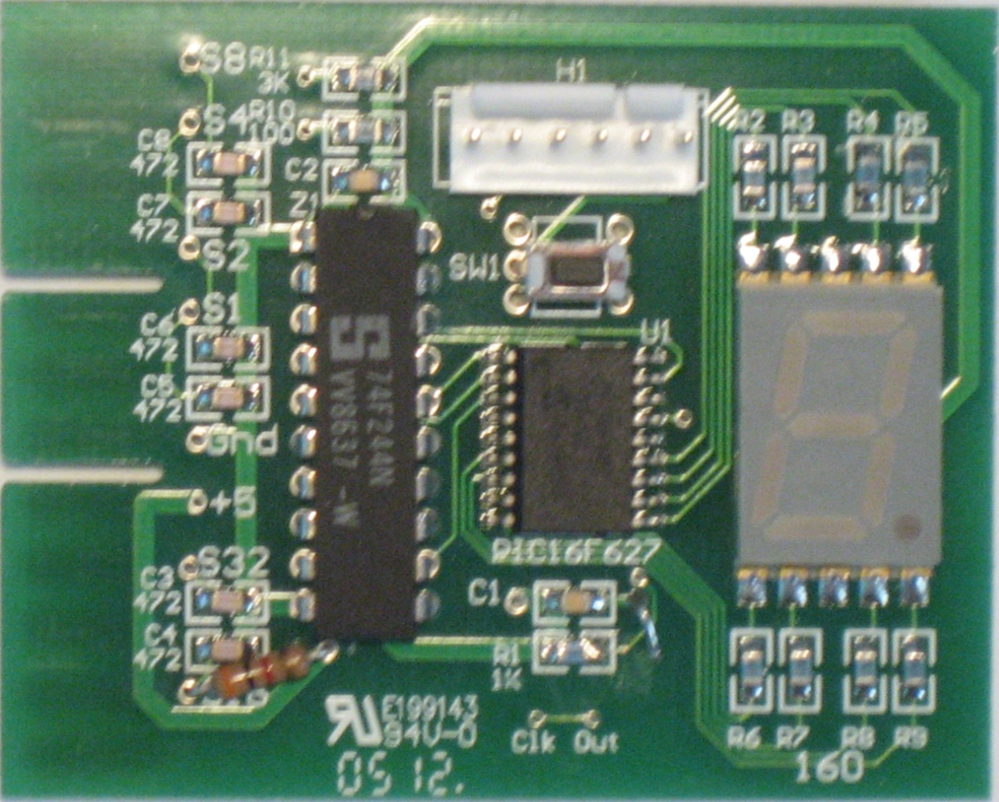
The programmer would depress the reset button, and then activate a switch on the playfield. The sound analyzer will then display the value of the sound vector(s) on the display. For simple sounds, this will result in the display showing a value of ‘A’ (for example) for each time the 10-point switches is pressed. The analyzer will cycle through its memory of switches, displaying all of the switches it has seen repeatedly, and in order, after this. So, in our example it would display an ‘A’; blank; pause, and then display an ‘A’ again. For more complex sound sequences, it would display an ‘A’, a ‘5’, another ‘5’, and then a pause before repeating this sequence again for a switch that utilized a sound sequence of 10, 5, and 5.

Figure 2 – Ni-Wumpf Sound Diagnostic Tool
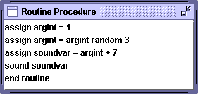
This sound analysis must be performed with an original, functional, Gottlieb CPU, in order to complete the sound table for what sounds are played with what switch. It should also be noted here, that Gottlieb did not always play the same sound for a particular switch. In fact many switches played a random sound from a group of sounds. Shown here is the routine used in Devil’s Dare to play a sound for the spot target bank, and many of the other spot targets (routine Random Scoring Sound). It can be seen that there are three random sounds used, a random value between 0 and 2 is calculated in the second line, and added to 7 to come up with the random sound elements 7 through 9. This variable soundvar is then sent to the sound board in line number 4. If you hooked up the sound analyzer to this game, and repeatedly pressed one of these spot targets, you would find one of the values 7 through 9 displayed on the LED in random.
As before, in other platform element definitions, several sounds will be consistent throughout the entire range of games for the platform, such as sounds 1 through 4; “Game Over”, “Extra Ball”, “Replay Button, and “Tilt”, and should be defined at the time that the platform is designed.

Adding the Software Routines
Up until this point, the platform design has been working toward defining the building blocks that a pinball platform design will use in its programming, i.e. how many solenoids, sounds, lamps, and displays there are. The other addition to this design phase has been to label some of these elements for later use in routines that will reference them, such as; sound 3 is the “Replay Button”. This initial phase will be important to the next phase – programming the common platform routines, because it is here that the IDE needs to know how to bound the components used in programming, and what to call some of them to aid in the reference of commonly named parts; it’s important to be able to refer to the “knocker” solenoid, rather than generic solenoid number 8 in order to prevent programming errors. It is also vital to the “point and click” programming design to only be able to make available to the programmer those elements that physically exist – it’s no good allowing the programmer to reference solenoids 1 through 64 when s/he could easily select a solenoid to be used that does not exist. Not only can this result in compilation errors, but would surely wreak havoc on the hardware API outputs. So, the first step of creating the hardware constraints has been necessary in order to enable this second step; of bounding these components made available to the programmer.
Each platform design has different components and routines available to it, but in general, it has been found that the platform routines can make up nearly the same number of routines used in coding as the game specific code does. Furthermore, the amount of code used in platform design will commonly outweigh that code made up for game specific routines! A little harsh for the platform designer, but great news for the game coder – most of his work is already done for him.
It is at this point that the programmer needs to understand the relationship of how platform code interacts in a backward fashion, with the hardware API routines, and forward, with game specific routines. Routines that exist in the hardware API of the UBQ libraries (that Ni-Wumpf provides) must be defined at that layer, in order to be referenced in the platform routine section. Furthermore routines that may exist in the game design, but which will only be programmed at the time of game coding, must also be defined and referenced here. Odd concept? Not really, it’s been around since the design of layered systems design. Base level routines that exist in an external library need only be “included” as a reference to those libraries in order to be used by the program. We are just defining all of those library routines here and now at the platform level.
So, routines that exist in base level code libraries will have the specific naming construct of <some routine name> API to identify them as such. For example, the programming line “call Clear Switches API” calls the Clear Switches API in the hardware library. When defining these routines at the platform level, the programmer does not enter any code into the routine defined - that code exists elsewhere, he only defines the name of the routine to be subsequently called by routines that he will write. Therefore, before writing any platform code, this next phase has been to create references to the base level library routines. Fortunately there aren’t that many of them, the next section describes each of the routines, and their functionality.
Conversely, forward referenced game-dependent routines that are to be called at the platform level of coding will be referred to as <some routine name> Hook. These routines are “stub” routines that will immediately return from the call if no game specific code is defined/written for them. In this way, a platform routine can refer to a game routine that does not yet exist, right at the time of platform coding. What does this do for the platform coder? Well, an example of this functionality would be the ball search routine – a routine to examine the outhole trough at game start to determine if the correct number of balls are present in order to start the game. Every game needs this functionality, and so it is used at the platform level at the time when the game-start button is pressed. However, at the platform level, there is no way to know what holes exist in the game that a ball may be caught in, nor even to know how many balls there are in the game and what to do for a multi-ball game. However, the functionality of a ball search routine is well understood – count the number of balls in the ball trough / outhole, if this value is less than the number of balls in the game, check anywhere in the playfield that a ball could be stuck, and eject the ball onto the playfield until the ball trough is filled with the correct number of balls. If, after a period of time, this routine fails to locate all of the balls needed for the game, return an error code to the platform routine. So, in the Replay Button routine, one of the first things the platform code does is to make a call to the Ball Search Hook routine before starting a game. Again, a “hook” routine that will be coded at the game layer of coding.
As a platform coder, these stub routines are created at platform design, with the expectation that the functionality will be filled in later. The compile and link process can proceed with unknown forward functionality, because the routine actually does exist in the platform code (though it doesn’t do anything), and won’t be overloaded in the compilation process until the game designer creates the same routine name, and puts in the corresponding game code.
In this second phase of the platform design then, the hardware API routines have been defined, and some of the expected software hook routines are defined as well. In most cases, this step involves little more than copying stub routines from another platform design and pasting them into the new design. No coding has yet been accomplished, but we’ve now got a number of routines to refer to, as well as the correct number of playfield parts to use. So, it is time to get down to coding the platform routines.

Hardware API Hook Routines
As described previously, there are game specific “hook” routines defined at platform coding that are forward referenced even at this phase of platform design. It should be noted here, that the same process was used at the hardware coding design layer. In other words, where we will be defining and referencing routines that will be later coded at the game level, the hardware API did the same exact process in referring to platform routines that it expects to be defined now! These routines will be named as “hook” routines as well, however, the hook, in this case, exists at the hardware API. A little confusing, so let’s look at an example of what is meant here. A perfect example of this would be to look at the power-up process of a game. Aside from the hardware routines to check out the operation of the CPU, what does every game launch right into, after it is powered up? It’s idle routine. Most games will do something for the potential user, to indicate, “I’m working – want to play?” In the simplest case, it may be the process of displaying the high score to date in an alternating fashion with the last scores for the game that just ended. Beyond this simple functionality, a whole animation process could exist. This is the Game Idle Hook. The hardware API cannot know how to idle a Bally game from a Gottlieb game, but it does know that the idle routine will exist, therefore it is referenced and used in the hardware library. There are only a few routines expected at the platform layer from the hardware API as tabulated below. Coding for these routines should be addressed first in the third phase of platform development.
Appendix ‘A’ lists each of the hardware API hook routines and their functionality.

Hardware API Routines Available
The routines tabulated in Appendix ‘B’ comprise the list of routines common across all platforms of the UBQ design - routines that are coded at the base level API linked into all of the software written. As such, the internal coding is not modifiable by the programmer; these routines are only defined in the platform design as entry points into the system libraries that can be subsequently called by routines at the platform layer. They are modifiable at the platform layer for developers that are putting together a new platform environment (besides the Gottlieb System 80).

Common Platform Hook Routines
Now that we’ve gone over the hardware API routines, and hooks – the primary layer of coding for which much of the rest of the software is built upon - it is appropriate to discuss the next layer of routine hooks used in the coding stack. The platform hook routines are placeholders at the platform layer, and get defined there to provide entry points to the compilation process. It should be noted at this point that any routine referenced at the platform layer whose name ends with a “Hook” is going to be a routine that will be fleshed out in the game writing section. Similarly, any routines referenced at this layer whose name ends in “API” are already written, and fleshed out in the hardware layer. Finally then, most games will need code at the game programming layer to complete the expected operation of the routines. These routines are tabulated in Appendix C.

Platform Design Coding
Finally, phase two has been addressed, and the components for phase three of the platform design have been reviewed. So it is time to address coding of the platform. In the previous layer (hardware) there were 2 routines specified that needed to be coded as hardware API hooks, 14 routines defined as hardware API entry points (that were coded into the previous layer), and 8 routines defined that are similarly not coded here, but forward referenced to the game design. So there are already 24 routines in the platform design, only two of which the programmer is aware of needing in his platform design. Obviously then, there is a lot more coding at the platform level to be addressed, and appendix D lists the balance of the platform routines used in the Gottlieb System 80 games.
The platform layer of game support is complete! Bear in mind that at this point, the game programmer should have at his disposal a set of common subroutines that control most of the common functions any game in that platform would perform. Tilting, scoring, awarding specials, and extra balls, etc. should all be coded at this level (and pretty much for all platforms too!).

Variables
If, by now, you have started up the IDE in a web-browser to view these routines, it is readily apparent that they use variables in all of their operations. Up until this point, the documentation has made reference to some of these, but never gone into what variables exist, how they are defined, and what types of variables are supported. A complete review of the defined platform variables available to the programmer is discussed in the section below.
Like programming routines, there are two classes of variables available to the programmer; platform variables and game variables. The difference between the two is minimal, the values can be changed and updated during coding of either type. The only caveat being whether or not the programmer can modify the type of variable that a platform variable starts out as (he cannot, in game design mode) - which, brings us to which type of variables exist, and where these variables reside in memory. As with other normal programming languages, the IDE supports a number of different variable types, consisting of “short” numbers (8 bits of data) that can handle numbers between 0 and 255; “integer” numbers (16 bits of data) that can handle numbers between 0 and 65532, and “long” numbers (32 bits of data), which are big numbers indeed, like player’s scores. Then there are Boolean variables (true/false) which also take up a byte of system memory when allocated. Lastly, the programmer is allowed to create “string” variables, which by default occupy 80 bytes of system memory – so avoid using a lot of string variables in your design!
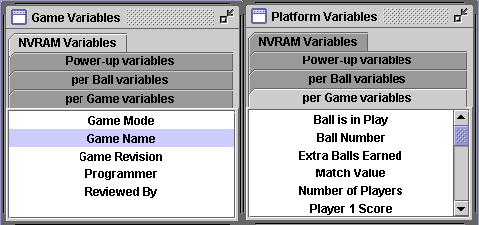
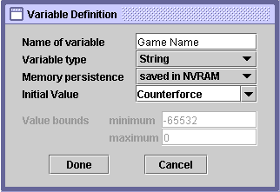
Looking at the variable definition window below, there are a number of fields to the entry panel besides what the name of the variable is and the type of variable it comprises; there is the initial value of the variable that it should take on when the game first uses it, the “persistence” of the data defining when the data gets initialized, and the upper and lower bounds which the variable can take on. Persistence refers to the time at which certain variables are initialized. There are NVRAM variables that are copied into main memory on power up, and subsequently saved back to non-volatile memory at the end of a game. These variables are only initialized in the game setup menu, and at the time the board is first programmed. The next most persistent variables are those variable that are initialized at “power up”, normally these variables would be used in routines and discarded at the end of the routine, such as scratch variables. The next most persistent variables are those that are initialized at the start of a game, or “game” variables, these variables are initialized once at the beginning of the game, and might include variables to track if/when a special was awarded during the game, the current “state” of the game, the ball number, whether the ball is in play or idle, etc.. Lastly, the most common variable is that type that is initialized at the launch of the ball, such as flags that identify whether a drop target is up or down, an extra ball available, etc.
Each of these variable types is identified at time of creation, and sets up the development environment to initialize each variable type within a single initialization routine called at; power-up, game start, and ball launch.
The last two menu entry items should define the minimum / maximum values that the variable can assume before a run-time error occurs. These “boundary constraints” should be specified at time of variable definition, however, at this time, the boundary values are not enforced.

Timers
One thing that traditional game coding lacked in the past was the use of a second processor capable of managing the system clock, and using that clock to decide when a particular event should be executed asynchronously of the default program/game flow. That is not the case here, the UBQ hardware design allows for any number of asynchronous events to be defined and then scheduled (or removed) for execution at some time in the future. The system maintains a list of these events to act upon, and uses the closest execution event in time to be sent to an external timer processor that is tasked with interrupting the CPU in its execution when the event elapses. The resolution of this timer is set to 1 millisecond, however, due to processing overhead, no event can be scheduled to occur less than 100 milliseconds from the time of code execution.
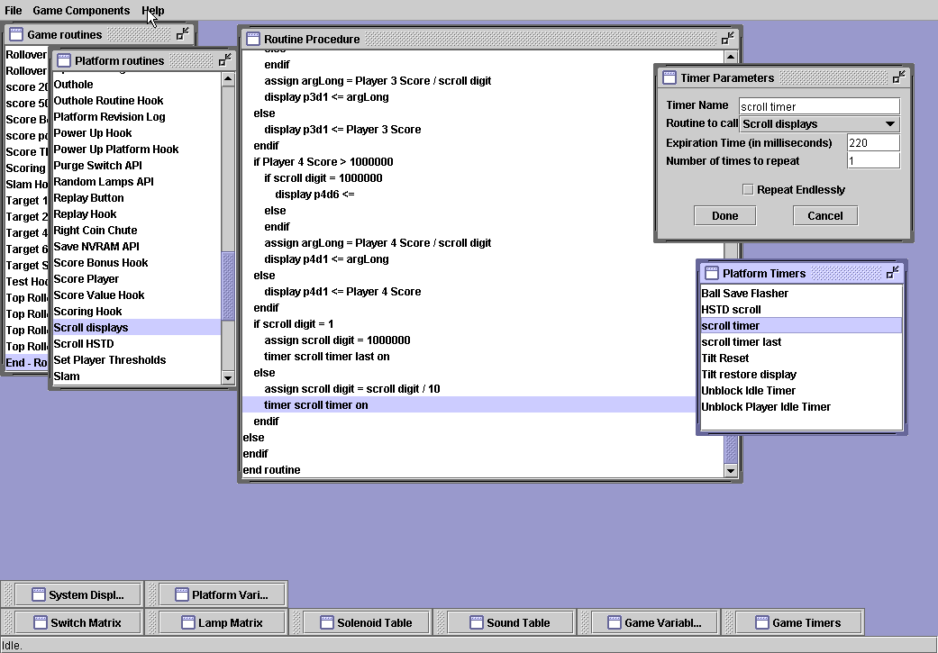
Timers work by calling a pre-defined subroutine once their expiration time has been reached. So, if one line of code specifies that a timer should light a lamp ½ a second from now, then when that line is executed, the specified lamp will by lit ½ second later w/out other programming intervention required. It should be noted however, that while timers interrupt the CPU to process the subroutine specified, the CPU will always complete the section of code it is running before jumping to that subroutine. This means that if the CPU was processing the code related to striking a particular switch on the game when the timer expired, it will complete that processing, and then immediately run the timer routine. Similarly, if one timer interrupts another timer routine, the first timer routine will complete before the second can run.
All timers work in a relative time reference, which means that any event can only be scheduled to occur some period of time from the exact time that the code that references a timer to turn it on is actually executed. It is not possible to schedule a timer to occur at 2:00pm.
A timer can be made to execute repeatedly, either endlessly, by checking the corresponding box in the timer definition menu, or a set number of times, by entering that value in the repeat box of the menu. Any repeated events will occur at the set expiration time from the moment in time that the preceding timer executed.
Once a timer is defined to perform a particular function, it is not actually active and put into the event queue, until the corresponding line of code calling that specific timer name turns it “on” (see above code snippet). Similarly, to cancel / remove any timer, including repeating timers, the same line syntax is used to turn that timer “off”, and remove it from the queue.

Adding a New Timer
Adding a new timer is accomplished in one of two ways; selecting the “Add Timer” menu entry from the main “Game Components” menu, or by focusing input in the Game Timers (or in platform edit mode – the Platform Timers) window, right clicking the mouse to bring up the pop-up action menu, and selecting “insert” to open up the Timer Parameters window.

Menu Commands
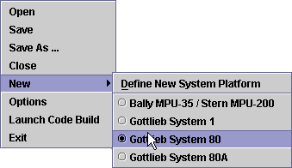
Open – the default menu command to open an existing game program. This will bring up a file browser window whose root directory is the “Pinball” sub-directory in the user’s home directory.
Save – the command to save the open game / platform program to the same filename from which it was opened from. Save often!
Save As – this command will save the open game / platform program under a new name in the default directory from which the original file was opened. A file browser window will open to enable the user to save it elsewhere, and to define a new filename.
Close – the “close” command should close all menus and dialogs. The IDE will prompt you to save any changes that have not been saved.
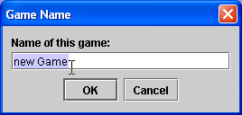
New – this is the menu command to begin a new game / platform design. The user selects the “new” item and then chooses one of the radio buttons available in the subsequent pop-up menu. The IDE looks into the user’s home directory -> “pinball/templates” directory for any and all platform definition files (files whose extension is “.ubq”), and then reads in each of those files to determine the platform definition type. That platform name is then displayed here (see above). Once the platform has been selected in this menu, a new game programming environment is generated to allow the programmer to code in a game. The first thing the IDE does at this point is to prompt the user to enter in the name for the game he is going to code:
Options – while there may eventually be more options to imagine while using the IDE, the very first thing to do when beginning or modifying an existing game program is to enter in your name, so that the new code can be tracked to the coder. This development process is a very open-source environment, and game designing and sharing is encouraged, it is therefore very important to know who to contact for questions on the game code being used. The programmer’s name is also used for locating your binary game code on the website once the code has been submitted for compilation. For this reason, it is extremely important to create a new developer directory tree by entering in your unique name in this dialog box.
Launch Code Build – Once a game has been written/modified, it is ready to be sent to the Ni-Wumpf server for code compilation, and subsequent download. The first step; uploading to the server is a simple matter of selecting this entry from the main menu list. The IDE performs the XML file transfer to the Ni-Wumpf server, and the server autonomously processes the file into a binary image from that (obviously, because the IDE is itself a web application, it is assumed that the programmer has an established Internet connection to perform this transfer). Be aware that these game files are not insignificant in size, generally around 1MB – and it can take a little while to transfer the file. Once the file is transferred, a separate process is required to download the file to the computer from the Ni-Wumpf server (discussed below). In general, it is necessary to open up a web browser window that uses the following URL; www.ni-wumpf.com/developers/<developer name>/ as the web address. This brings open a file window with three files there by default; the binary code just compiled; main.bin; the memory map of the image just compiled; main.map; and the compilation results file; results. These files are discussed more in detail below.
Exit – Pretty self explanatory eh?

Command Syntax
As mentioned previously, the programmer isn’t doing too much typing in the IDE, this is a development environment designed around piecing together the parts of an instruction for the game to complete, from an intuitive process of “do something” with “something applicable”. As a command is entered, the next possible fields to operate the command with, are pre-selected and displayed to the user. In this way, programming is pretty much reduced to point and click.

The process of entering a command
Routines are a list of commands to execute. So the first place to begin at learning the command syntax is in one of the game routines in the Game routines menu. Presuming that the programmer has a game open for editing in the IDE, select one of the routines from this menu by clicking on that routine name. Once this is done, the Routine Procedure window should open (or, if already open, change) to display the commands of that routine. In the Procedure window, select any one of the command lines already written. Now that line will be highlighted, and it is at this position in the code that further command entry will commence. Hitting the <ins> at this point, will begin the process of entering a new command on the line just prior to the highlighted line. And the first step in this process is to select a command from those commands available. All code lines begin with the command directive as the first word in the syntax, and section 8 covers all of the commands available to the programmer. Operations such as assigning a variable some value, or testing the contents of some variable for conditional execution, right out to jumping around in the code or calling a subroutine is part of this first step in the procedure.
Because many commands offer the ability to terminate the command at different points in the syntax, it is important to know a few syntactical notations. Let’s illustrate this idea; the difference between the command “a = b” and “a = b + 3” is the fact that right after the variable “b” is entered, the programmer ended the command in the first case, but continued the command in the second, to add in the “+ 3” part of the command. So, the IDE will end the command whenever it is syntactically possible whenever the programmer hits the <Enter> or <C/R> to terminate the command (in the first case, right after the “b”). Conversely, at this same juncture, the programmer can choose to continue the command with more operator input by using the <space> key to continue the command.
In the event that the command cannot be terminated at the menu/entry point where the user is working, then either the <Enter> or the <space> key will continue the command. And finally, to abort command entry, the <esc> key will erase the current command entry entirely.
There is no limit to the number of fields allowed in a command line entry, however, the IDE has one serious limitation in presentation of line entry elements. Depending on how wide the Routine Procedure window is made, entry of the command line can come up against a word wrap problem, which, when encountered places the next field entry box on the next line of the line being entered. When this happens, the fields in the entry box are truncated horizontally, such that the content value is unable to be displayed. Unless the user hits the down-arrow key to pop-up the entry box for field entry, the fields will be hidden from view.

Editing Command Lines
There is no editing an existing command line – forget about it. Once a command has been parsed and entered, it is an XML construct too complex to edit within the rules of the IDE. To correct a line entry, the easiest process is to re-do that line entirely.

Programming commands
All of the programming commands available to the user are displayed immediately at first launch of command line input. These include the following commands:

assign
Syntax: assign <resultant operand> = <operand> [<assignment operator> <operand> …]
The simple assignment command is used to set a variable equal to a specific value, or the value of another variable - this command works on all types of variables, and uses appropriate operators for each variable type. So, for example, you can assign all forms of numeric values to any other numeric value regardless of the integer size. I.e. a short integer can be assigned to a long and vice versa. Any value too large for the containing variable type however, will be truncated.
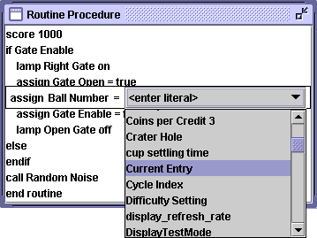
The IDE enforces strict type checking when creating any command that uses variable assignments or comparisons. This means that as the command is being entered, as soon as the first variable type is determined, all other variables, and operators are restricted to the list of possible entries that can work with that variable type. Obviously, it makes no sense to allow the programmer to assign a string of characters to an integer variable, and the IDE won’t allow this. The way that this is enforced is through the menu selection of operands as shown here. Once the variable type of Ball Number is determined, only those variables of compatible types (integer) are allowed to be displayed as assignment operands.
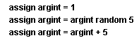
In a complex arithmetic calculation, it may take some effort to code in the equation that you are trying to express. For example, if I want a random number between 5 and 9, the command must be broken up into three statements. Here is why – any time a literal value (as shown above as the default option in the operand box) is entered into a command, the command terminates after the value is input. A carriage return has to be entered to terminate any literal, and this terminates the command as well. So this operation winds up looking like the statements shown to the right. As you can see, the difficulty lies in the fact that the equation “argint = 5 + random(5)” uses a couple of literal values (the ‘5’s) to complete the evaluation.

Order of Evaluation
The order that a complex equation is entered into the IDE may have an impact on the expected result if precedence is not considered. The IDE evaluates arithmetic functions from right to left in a stack-based process without arithmetic precedence applied. This means that the equation “4 + 6 * 3” evaluates to what you would expect: “22”. However, “4 * 6 + 3” is not “27” as expected, but “36”! Be careful!

Assignment Operators
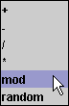
Each variable type has a number of possible operators that are valid when entering a command line statement. The list of arithmetic operators available to integer-type variables are shown to the right, and include; ‘+’, ‘-‘, ‘/’ (divide), ‘mod’ (modulus), and ‘random’ (return a random number between ‘0’ and the right-hand operator). Be aware that a divide operation will truncate the results to the next lowest integer number to the decimal result (i.e. the result of 15 / 4 is ‘3’ not the closest number ‘4’). The ‘random’ operator is actually interpreted as the result of any random number between 0 and the right hand operand – not including the right hand operator. For the statement shown above for example, (“argint random 5”), the result can be any number 0, 1, 2, 3 or 4.

Boolean operands can use only the logical operators ‘and’ and ‘or’, for a logical evaluation of the operands.
String operands can only use the append operator (‘+’), because there is only a single possible operand here, the operand box is omitted from user prompt.
There are no binary operators.

call
Syntax: call <subroutine name>
Any routine can call another, and the “call” selection is the command that will bring up a list of all the available subroutines defined in both the game and platform layers of system programming that can be used. The operation is pretty straight-forward, a call to another routine causes program execution to begin working on that routine until completion, at which point, the original routine continues to process the command immediately following the “call” command.
Note: Do not mess around with recursion here – the system has limited stack resources (2 kbytes of stack and variable RAM space). This means that the system is probably capable of handling a dozen or so levels of subroutine nesting before the stack gets deep enough to threaten underflowing the variables address space.

go to
Syntax: go to <label name>
There are two parts to an unconditional change in program flow; the “go to” command to actually branch to a pre-determined label; and the destination label declaration itself. Be aware, that the system has no way of knowing where a label exists in the code when it allows the user to enter the “go to” command, therefore it is entirely possible to attempt to program a go to command that branches outside of one routine into another. This is not good practice – all “label” / “go to” constructs must exist within the scope of a single subroutine.

if
Syntax: if <conditional expression>
<statement>…<statement>
else
<statement>…<statement>
endif
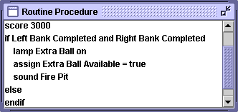
The conditional execution statement; if something is true, then do one thing, and if not, do another. It’s a pretty simple idea, though the IDE implementation is going to enforce some structure around this logic. Once an “if” statement is entered, it generates not one line of code, but three; the “if” statement itself; the “else” statement delineating where the logic starts should the conditional prove to be false; and the “endif” statement that delineates where the contrary logic ends. Any statements entered into the IDE between the “if” statement, and the “else” statement are executed if the conditional proves to be “true”. Any statements between the “else” and the “endif” statement are executed if the conditional proves to be “false”.
The expression that is used in evaluating the “if” statement itself, can be as complicated as any assignment statement, allowing for complex arithmetic evaluations of the right-hand operand prior to comparison to the left operand, as well as combining any number of logical evaluations between operands. All arithmetic evaluations follow the same logic as described in the assignment operation above – that is, the results of an evaluation are truncated/evaluated along the same rules.
Deleting an “if” construct will cause the IDE to clean up only those components of the statement itself. That is; deletion of the “if” statement line itself will remove the “if” statement, it’s associated “else” statement, and finally, the “endif” statement at the end of the command. All of the statements within the “if” construct will remain intact after this action. Attempting to delete the “else” or “endif” statements of an “if” construct will result in no action being performed. However, attempting to copy an “if” construct to the clipboard buffer requires the user to completely highlight all of the statements used in the construct. Partial highlighting of the entire set of statements will fail to update the clipboard. This can severely impact a “cut” to the clipboard, because will the initial copy will fail, the subsequent delete of the statement lines will succeed!

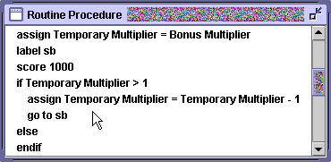
label
Syntax: label <label name>
A “label” statement is a location target for a “go to” instruction. Each label statement must use a unique identifier, and that identifier is any string value that is entered in the “literal” field entry box that pops up once the “label” command is started. If the programmer attempts to enter a string that has already been used as a label elsewhere in the game code, the IDE will not accept the entry or terminate the command. This includes labels that may have been defined as part of the set of platform routines that the game program is using. So while it can be confusing to be denied the entry of a label that you have never defined before in your game code, you can be sure that if the system won’t accept the value being entered, it was previously defined in a platform routine, or it was defined earlier and then deleted (the system has no way of keeping track of deleted labels).

lamp
Syntax: lamp <lamp number> <on / off>
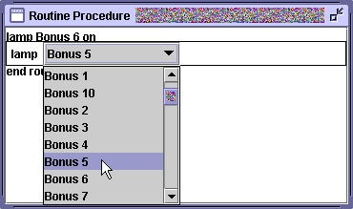
In past commands we dealt mainly with program flow and execution – now, it’s time to discuss the real functionality of the game coding environment – controlling the hardware in the game. The first of these is the “lamp” command which controls the playfield lights, and generically it is used to light or douse a specific lamp named in the lamp table. As shown in the code snippet to the right, once the “lamp” command is started, the IDE will display a list of all of the named (and unnamed/numbered) lamps available on the game platform to control. Following this field entry, the last field of the command is whether to turn this lamp on, or off. It should be noted, that turning a lamp off that is already off, doesn’t really accomplish much (and the converse is true as well).
Now, this is a great procedure if you want to control each lamp via a specific naming convention, however, it is very restrictive if one wishes to calculate what lamp to operate on, and later on, control that lamp. For this reason, one additional entry to the lamp selection pull-down list shown above, is the first value; lampvar. lampvar is a variable representing any numbered lamp on the playfield. Therefore, if you want to address any of the 48 numbered lamps available on the System 80 platform indirectly via it’s specific lamp number, you would first assign that lamp number to the lampvar variable, and subsequently use the lamp command to use that variable in a control statement.

rem
Syntax: rem <string comment>
The “rem” command is short for “remark”, and is the indication for a simple comment statement. Comments are used to explain what may be happening in the current code segment that should be explained. They are not executed and have no impact on program flow. The limit of alphanumeric input allowed on a remark statement is 80 characters.

score
Syntax: score <numeric value>
Here is the big one – scoring points! That is, of course, the entire idea behind playing pinball, and despite this immense responsibility, the “score” command is trivial. The numeric value contained in the referenced variable of the operand (or the literal value entered into the command in it’s place), is added to the current player’s score, and that score is updated on the player displays. The platform code will also perform threshold checking at the same time to determine if there is any particular award available for passing a certain scoring threshold at the end of this procedure.

solenoid
Syntax: solenoid <solenoid number>
Energizing a solenoid on the playfield is the simple process of issuing the command to fire the associated solenoid number. The hardware of the Ni-Wumpf CPU handles the timing associated with energizing the coil for the correct amount of time, and then de-energizing the circuit after the pre-defined period of time associated with the platform circuitry. The solenoid number is taken from the game solenoid table and should represent the naming convention associating each of the coil numbers with a coil name.
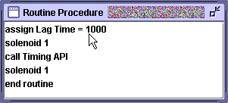
There is an option in the command to fire a solenoid “reference” value. This reference value, when entered as a literal, overrides the automatic system timing and control of the solenoid circuits, meaning that the CPU will energize the solenoid, and leave it energized! Be very careful when entering a literal value for this command! You can fry the hardware very easily. The code snippet shown to the right demonstrates the method used to override the default solenoid firing timing for the first solenoid of the game. The second command in this list energizes this solenoid, while the fourth command toggles this command, and de-energizes the solenoid. From above, the period of time that the solenoid will remain energized is 1000 mSec. or 1 second. There is no ability to correlate a name with a solenoid number in this case. In fact, it is the presence of a literal value in the solenoid operator field that causes the IDE to interpret this command differently to the hardware control logic.

sound
Syntax: sound <sound number>
For those games with sound definitions in the platform environment, the game programmer has the capability to name/identify the sounds associated with the numeric “vector” values of the table. In other words, like solenoids and lamps, the logical output from the game code of a numeric value to the pinball subsystem (solenoids, lamps, and sounds), causes the associated sound to play. So the first sound on the sound board will play if you command the system to play sound number 1. Like the solenoid command shown above, the syntax is simple, use the sound command, and select the sound to play from the list of sounds shown.
Like the lamp command there is one additional entry to the sound selection pull-down list; the first value; soundvar. soundvar is a variable representing any numbered sound on the soundboard. Therefore, if you want to address any of the 32 numbered sounds available on most System 80 boards (some only have 16) you would first assign that value to the soundvar variable, and subsequently use the sound command to use that variable in a control statement.
On the system 80 platform, the sound board operates in the following manner; a sound vector is sent to the sound board across the control lines going from the CPU, through the driver board, and thence to the sound board. Once the sound board receives this vector, it plays the associated sound for as long as the length of this sound natively exists. No other output from the CPU is necessary (or possible) to stop the sound, and in some cases, interrupt the sound. Additionally, there are some sounds on various versions of the sound board, that comprise a sound that is an endless loop. These sounds normally start playing once commanded to, and repeatedly loop endlessly (as in background sounds) during game play. Only another specific sound vector sent to the sound board will cause this background sound to stop playing. Normally, most sounds that are playing, will be interrupted (and stop playing), once the command to play another sound is received.

timer
Syntax: timer <timer name> <on / off>
Chapter 5 describes the theory behind asynchronous timing events. And it is this command that starts or cancels a pre-defined timer event. As in most of the previous commands, the entire statement consists of the timer command, followed by the name of any of the defined timer events from the subsequent pull-down menu, and the selection of whether to start this timer or stop it. Stopping any timer that is not currently scheduled to run has no affect.

General Editing
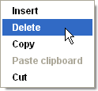
While editing an existing command line is not possible, editing sections of code is certainly available. In fact, right click in any routine, timer, or variable window and you will be shown the same editing options given in the popup menu to the right. Single lines, or entire sections of code/variables/routines can be copied, deleted, and/or pasted.
By highlighting any number of lines in any of these windows (Game Routines, Routine Procedures, Game Timers, and Game Timers) the contents of the entries can subsequently be copied from one game design to the next – simply highlight the routines that seem appropriate in one game, copy them to the clip board, open up the game where they should be moved to and paste them into the Game routines window. Routines, can be copied this way as well as timers, variables, and lines of code. But, be ‘ware! This is one of the only ways to corrupt your game code, and create code that cannot be compiled. Copying routines from one game and pasting them into another is fraught with peril - the IDE does not (at this time) perform rigorous checks on the content of such a routine. This means that any references to variables that were not copied from the source design into the destination design as well, will be unreferenced in the current design. It is one of the few loopholes that the programmer can use to defeat the IDE constraint checks. Similarly if a routine makes reference to a subroutine that exists in the source of the copied design, but not in the destination design, these routines will be unreferenced as well. Which goes for timers, and labels as well.
Highlighting lines of code is a matter of clicking on that line to select it. If the <cntrl> key is depressed at the same time, that line of code will be added to any existing selections. If the <shift> key is depressed at the time, then all lines between this current line, and any previous selection will comprise the selection set.

Renaming entries
A fast way of creating a set of variables, such as Booleans for each target in a drop target bank, is to define a single variable (ex. “red drop #1”) for the bank, copy it, and repeatedly insert it into the variable window resulting in a bunch of variables with the same basic name that have a “[1]” naming extension to them. By double clicking on this variable name, however, you can quickly rename it to the correct value (ex. “red drop #2” et. al.) This practice pertains to routine names and timer names as well.

Coding a Game!
Finally! The section of the manual that actually explains the process of coding up a game! This process generally follows the steps below.

Fill in the Preliminaries
First, name the game: you can copy an existing game to a new game by loading a target game, renaming the game, (using the “save as” command), and then reworking the existing code to begin writing your game. You can take one of the platform templates provided, save it as a new game name, or you can start from scratch by selecting the “new” command from the “file” menu. Generally, it is easiest to begin coding from one of the platform templates for the platform you are coding with; e.g. open the “System 80 template” game, save it as the new game name, and begin coding. Now you have the tables established to begin using their entries in game commands.
Enter in the game tables from the existing game manual into the IDE: all Gottlieb System 80 games come with a manual defining; the switches on the game in the original switch matrix; the names of each of the solenoids from the 9 available solenoids on the system; and the names of the lamps used on the game, sometimes shown in a matrix, often listed in a list. It should be noted that the switch matrix shown in most System 80 game manuals is reversed in appearance from the matrix to be entered into the IDE. I.e. the switch strobes are listed vertically in the manual, where the strobes are entered in on the horizontal axis in the IDE. Regardless of this appearance; switch number 75 in the manual is still switch number 75 on the game. Similarly, the lamps numbered 1 through 48 in the game manual correspond to lamps designated ‘00’ to ‘b3’ in the IDE, which can be pretty confusing at times.
Note before proceeding: enter in your name! If you have not done so yet, you must input your name as the game developer (through the ‘File’ -> ‘Options’ menu item). You cannot compile, and download any game code until a unique programmer name is entered.

Prepare the Game Hardware Components
Many games have unique physical design constructs that affect programming basics, such as lamp controlled solenoids, gobble holes, and multi-solenoid controlled banks (two assigned solenoids necessary to reset a bank). It is best to get a handle on your game immediately prior to coding. The logic behind this is to have a routine in place to handle commands that would normally (and easily) be programmed via direct commands.

Define Lamp Actuated Solenoids.
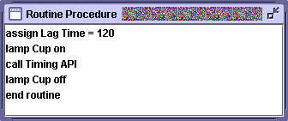
On games where game solenoids are controlled by lamp transistors, the normal command to actuate a solenoid is not available to the programmer. Therefore, it can be distracting to follow the code flow with these solenoids, without a good software practice put in place to help ease this confusion. It is suggested that the programmer create a discrete routine dedicated to performing the same function that a single line of: “solenoid x” would do.
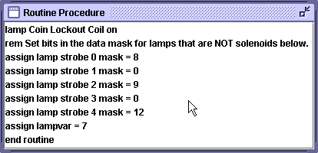
Solenoids that are to be controlled by lamp transistors need to energize for the same period as a normal solenoid automatically would. In the Cup Kick out routine shown above, the name of the lamp transistor is “Cup”, and the call to the Timing API, holds the solenoid (via the lamp) energized for the requisite 120 milliseconds. Therefore the statement; “call Cup Kick out”, performs the same functionality as a “solenoid Cup Kick out” statement would, if it were a wired solenoid.
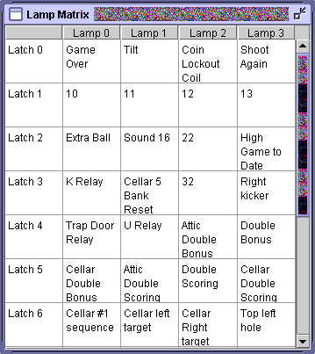
Another integral part of defining lamp controlled solenoids is to exclude them from the default platform routines that douse (and light) all lamps in the platform. This is done by specifying values for the lamp strobe variables in the Power-Up Hook routine as shown in the Routine Procedure above. The variables of lamp strobe “X” mask represent bit mask values for the corresponding lamp data value that is “and”ed with the data to be sent to the lamp latch logic on the driver board. I.e. looking at the lamp matrix to the right from Haunted House, row 0 in that table corresponds to the lamps that are affected by the lamp strobe 0 mask variable. The value to be used in the variable should be a bit mask representation of the digital value of this row’s entry for those columns that represent valid lamp entries (Lamp columns 0 – 3) in that row. From the table then, bit ‘0’ would correspond to the “Game Over” relay, bit ‘1’ would be the “tilt” relay, bit ’2’ would be the “coin lockout” relay in the front door, and lastly bit ‘3’ would be the “Shoot Again” lamp in the backglass. Of these bits, the first three lamps actually correspond to coils/relays, and are not lamps at all – only the last bit; bit ‘3’ is a valid lamp. The decimal value of these bits; ‘1000’ is ‘8’; the most significant bit, bit ‘3’, is in it’s correct position at the left as the third bit of the bit mask, and makes the lamp strobe 0 mask assume a value of ’8’ as shown in the routine. Following down the table; there are no valid lamps for Latch ‘1’ – row 2, therefore lamp strobe 1 mask is ‘0’; row 3 has two valid lamps at bits ‘3’ and ‘0’, therefore the value of lamp strobe 2 mask is ‘9’; etc..

The Ball Search Hook Routine
There is one assumption that most people forget when starting up a game to play – and that is that the game will have all of the balls necessary in the ball trough prior to the game beginning. The Ball Search Hook routine is the code used to clear the playfield, and get all of the balls out there back into the outhole trough. While this routine may wind up being executed only once, the logic behind this is fairly straight-forward: don’t start a game that can’t be played correctly. This is especially important when coding up multiball games. Take “Black Hole” for example, if you could start up a game of Black Hole with a ball stuck in the lower playfield kicker, you would quickly find yourself with a blown up-kicker solenoid. And yet, if our coding is good enough, how could balls wind up anywhere but in the trough after a game is completed? Simple, the game never ended normally, – the power went out, the game got a slam tilt, and we didn’t clear the balls afterward, somebody tripped on the power cord, or the game was intentionally shut down mid-game.
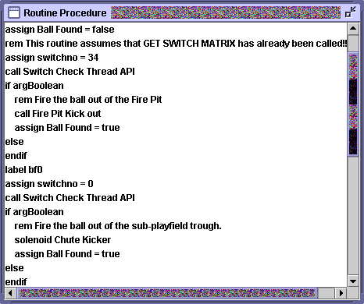
The Ball Search Hook routine will be called prior to the start of each game by the platform code.
Procedure: identify all of the holes/ball traps on the playfield that could have the ball stuck in place as a result of a previous shutdown. Each of these spots will have a switch associated with the position to indicate that the ball made it there, and that the game should do something with it. These switches have to be identified and then examined in order to see if they are activated. In the code shown to the right (from Devil’s Dare), the Ball Search Hook routine has already determined that the ball trough does not have the three balls necessary to start the game, using a call to the GetSwitchMatrix routine. Because flushing the balls out of the playfield before the beginning of each ball is a normal part of the game, the Ball Search Hook routine was broken into the check at the trough, immediately followed by a call to a routine called Ball Flush. The first switch checked here is number ‘34’ – the upper “fire pit” followed by a check for the ball in the lower playfield chute – switch number ‘0’. It may be useful to test this routine prior to further coding by compiling just this code with a call to the Ball Search Hook routine as the Test Hook procedure. Download and install the code, put a ball in various spots on the game for the test, and use the ‘0’ command to run the ball search check.

Ball Launch sequence.
Once the ball can be gotten to the outhole via the ball search routine(s), the next hurdle is to properly get it into the shooter lane. It is the Ball Launch Hook that handles this, but for the most part, this routine does a lot more processing than the routine it calls; the Ball Shooter Hook. So, when starting the programming on a new game, the simplest way to begin is to put a line in the Ball Launch Hook routine that calls the Ball Shooter Hook. Then in that routine, energize the outhole, or ball gate release to get the ball in play. The other code that should go into this routine at the very beginning is to reset the solenoid banks and clear the switch queue by calling the Clear Switches API. Lastly, a call to the Douse Lamps API will setup up the playfield for lighting of those lamps that start lit at the beginning of the game.Subsequent programming can build on top of this.

Program the Outhole routine.
Once the Ball Search routine is coded and tested, and the game can put the ball into play, the Outhole routine can be programmed, which forms the backbone of the processing that takes place between balls and readies the playfield for a new player/ball. Generally, however, the Outhole routine evolves from first strokes into a more complex routine. The one thing that the programmer should do at the beginning of programming is to plan for a multiball game or not. If the game has a single ball, not much more initial programming is necessary than what has already been done before the programmer can begin programming the game. If, however, it is a multiball game, the programmer should plan for the logic right away.
In a multiball game, this can be complicated from the perspective that the outhole switch no longer signals the end of the current ball – there could well be multiple balls in play on the playfield. Under these circumstances, the approach taken is to shift the routines that normally would be executed when the ball hits the outhole switch from Outhole to some other switch routine. However, because it is the platform layer that calls the Outhole routine directly at the platform API, it becomes necessary to rename the switch name from “outhole” to something else. This corresponding routine will then need to call the default Outhole platform routine after processing the logic of how many balls are in play. The logic behind programming the outhole routine should follow these steps:
- If the game is a multiball game, and the programmer has renamed the switch from “Outhole” to “Outhole Trough” (for example), the Outhole Trough routine is called on entry of any ball in the outhole, it is this routine that will eventually call the Outhole routine. Before that, however, the programmer will need to get the ball into the ball trough (energize the outhole coil), do whatever logic is needed to maintain track of how many balls are on the playfield, and then decide whether or not to call the Outhole routine (multiball). Aside from that modification, when the ball hits the outhole, within the platform API the Outhole routine runs, and calls several other routines as well:
- If no points have been scored between the time the ball was last put into play, and the time that it re-enters the outhole, or if the “ball save” is still active, normally the Ball Shooter Hook routine will be called again immediately, which basically puts the ball back into the shooter lane as if it had failed to do so to begin with (and with a bad outhole solenoid – this is completely possible.)
- Next, the Outhole Routine Hook is called; a game level routine to handle all of the logic that should be processed at the end of a ball – it finishes the current ball logic, and may perform resetting of timers, saving off any playfield conditions between players, etc..
- Then the game level Score Bonus Hook routine is called from the platform API to sum up the bonus value scored. The game will briefly flash the high game to date score right after this and decrement the ball number, or extra ball count.
- Next, the Ball Launch Hook routine is called – this is the game level routine that performs the logic necessary to prepare the playfield for the beginning a new ball, such as resetting target banks, starting timers, and doing the mirror processing that was done at the end of the last player’s ball - restoring the player’s saved settings, etc..
- Lastly, the Ball Shooter Hook is called, whose sole responsibility is just to get the ball back into the shooter lane.

The Attract routine
In game idle mode, when no one is playing the game, the system has the ability to try to attract players to come play the game. Normally, this is a simple playfield light show, but it can be anything the programmer has in mind. Procedurally, the platform API will call the Animation Hook routine at the game level to perform this attract routine, and for most games, this procedure will be nothing more than starting up the Animation Timer and then exiting. For
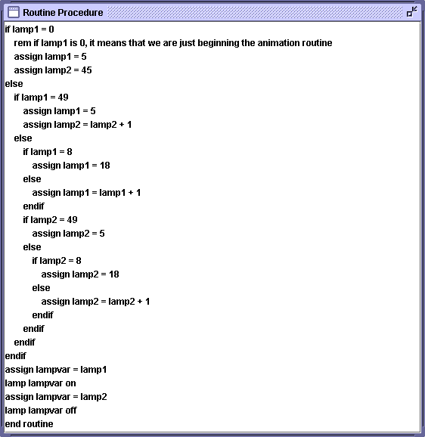
the Volcano game, the procedure is shown above, and it just goes through and cycles all of the playfield lamps in order. As can be seen, lamp1 and lamp2 are game variables that keep track of the lamp number to turn on next (lamp1) and the lamp number to douse at that time (lamp2), all of the lamps between these two values will be on. It can be seen that lamp numbers 6 through 17 are skipped over, and are likely to be lamp controlled solenoids. For this reason (lamp controlled solenoids), it is pretty important to code this routine carefully, or the animation routine will burn out the playfield solenoids. This segment of code is a listing of the Animation Routine procedure, and it is scheduled to be executed every 200 milliseconds via the Animation timer timer.

Drop Target Banks
Coding drop target banks follows a pretty standard format. Once the drop target switches are named, each drop target should have a Boolean variable associated with it to indicate whether it is up or down. One last Boolean variable would be assigned to the entire drop target bank to signify whether or not the whole bank has been completed. Each drop target has an associated routine with it that sets the Boolean variable, and subsequently calls a single bank completion check routine that would determine what to do when all of the bank’s drop targets have been hit. It is that routine that would reset the target variables to their initial value, and presumably activate the solenoid to reset the bank. That’s a simple drop target bank, and usually some of the first coding put into a game.
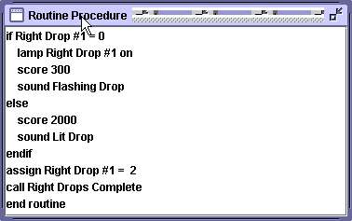
For games that work on logic that is dependent on counting bank completions or scoring the target based on how many times a target bank has been completed, the variables need to migrate from Booleans to short integers that count the number of times a target has been knocked down. Below is a coding excerpt from “Devil’s Dare” that is typical of each routine written for the five drop targets in the center drop target bank. The variable; Right Drop #1 is initialized at each new ball to the value of ‘0’. When the target is struck, the variable is set to the value of ‘2’. At the end of the routine, the Right Drops Complete routine is called to see if all targets in the bank have been struck by adding up the values Right Drop #1 through Right Drop #5 to see if the sum is equal to ‘10’ (five times ‘2’). If so, the bank is reset, and all of the variable values are then set to ‘1’. Referring back to the code segment to the right, it can be seen that the scoring for the targets is now changed – the targets are worth more, now that they have been hit once, because the bank target variable is now ‘1’, and not the initial value of ‘0’. Yet the summation process in the Right Drops Complete routine remains the same.

Cups and Launch Pockets
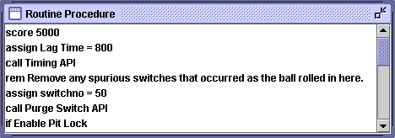
Getting the pinball to act correctly when required to control it’s behavior via event-driven software is always a question of timing. And the simplest form of this example is when the pinball drops into a pocket, cup, or even the outhole. A certain amount of time is necessary to allow the ball to settle down in the cup before attempting to pop it back out again. Additionally, since cups tend to score points, it is prudent to flush out the switch ‘Q’ of entries for that cup that result from the pinball rattling around in the cup, generating multiple switch closures before settling down. This is especially true of the outhole. The logic above demonstrates the code that runs when the pinball enters into the top ball ‘pit’ of ‘Devil’s Dare’; the game scores the cup, and then waits nearly a full second before clearing the switch ‘Q’ of switches for the cup, and then firing the ball out of the lane. If, when programming your game, you find that your outhole or cup is firing more than once for an event, you can be sure that you need to clear out the switch ‘Q’ of multiple switch detections before beginning further processing.

Manually Overriding the Solenoid Timing Cycle
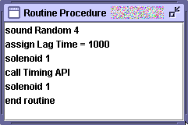
One last obscure hardware challenge may arise that will require unique programming techniques to address. One of these is the case of extending the pulse width used for activating solenoids on the game. In “Volcano”, the case arose where the default solenoid activation times just could not handle the full throw of the solenoid. I.e. where the default activation time on any solenoid is around 180mSec.s, this solenoid on the trough gate had to be activated for a full second – no adjustment of the solenoid_pulse_width was going to help problem (this is not a dynamic variable anyway!).
The code snippet to the right is shows an example of how to program a ball release gate (for Volcano) that is controlled by a normal playfield solenoid circuit. The call to the “solenoid” command is made with a numeric value rather than a reference to the solenoid out of the solenoid table. When the cross-compiler comes across this numeric value, it generates a different system call to the FPGA circuit to turn on/off the solenoid (it toggles), without engaging the timing circuit. The user is then responsible for coding the specific time lag, using the call to the Timing API, to hold the solenoid circuit up until the subsequent call to the “solenoid” command to toggle the solenoid off again.

Extra Ball / Special Logic
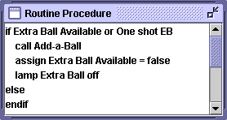
Awarding specials, and extra balls is a relatively simple process, complicated only by the fact that there are “factory” settings that could restrict the logic. For this reason, the programmer should call the platform routines; Add-a-Ball, and Award Special to handle the logic behind scoring an extra ball or a special respectively. On the right, is the logic that can be used to award an extra ball, and as can be seen, any number of extra balls can be awarded during ball play with this logic. However, the same cannot be said of the special award - platform logic at this time, sets a variable to check prior to awarding a special that, when run again prevents the player from getting a second special during the same ball.

Multiball Logic
As described above, most of the issues pertaining to multiball logic revolve around getting the outhole programming right – i.e. counting the balls in play and knowing when to finally end the player’s ball. This challenge is greatly complicated by some of the playfield designs that do not give the programmer any hardware sensors to actually count how many balls may be in the trough! But that is not normal – what is normal is to have the programmer ignore these switches when trying to code the logic, and here is why this can happen. Given that a ball will roll over all of the trough switches (when the trough is empty), before it finally comes to rest next to the ball shooter lane, it is obvious that coding routines that execute when these switches trigger is not a good idea – there is no way to know what is going on with the game. So, these switches have to be checked asynchronously to know how many balls are in the game – yet, if everything is programmed right with the game, the logic will already know how many balls are in the trough w/out checking these switches, merely by counting the times it energized the outhole coil to clear the ball into the trough. However, there are times when the outhole will misfire, either it went off too early while the ball was bouncing around chaotically, or the ball somehow managed to flop back into the outhole after a weak firing. Now the game has the wrong count of how many balls are in the trough, and a ball in the outhole – clearly a problem.
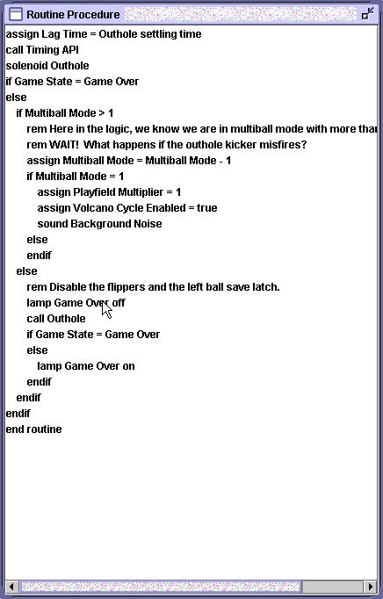
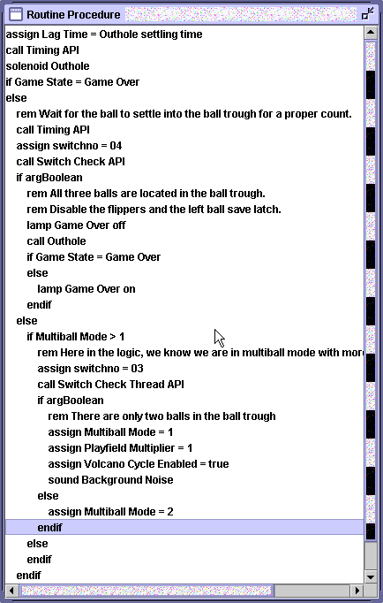
Above is illustrated two possible ways of coding the outhole routine for Volcano using logic on the left, that assumes the outhole coil will not fail – it’s quick and works well, but a bad outhole launch breaks the game. On the right, is the fault-tolerant version of this logic, the advantages; recovery from a bad outhole firing; the disadvantages; it takes longer to code, and more “wait” cycles to execute. This means that during the times that the Timing API is executing (the “wait” cycle mentioned), no activity is going to be noticed on the game - no scoring, and no additional sounds, which, in a multiball game like this, may be noticed by the player. This could impact the game as well. Now, it’s up to the programmer to weigh the coding options and decide what is best!

Adding Entries Into the Game Setup Menu
Right now, there is a game setup option to provide the operator the capability to program the value of DIP switches with a binary value to represent the settings of the old switch 31 and switch 32 on the original CPU board. Bit number 1 reflects the value of switch 31, and bit number 2 reflects the value of switch 32. Therefore a value of ‘2’ in this field means that switch number 32 is set, and switch 31 is not. However, it is obvious that the user would need to know what these switches meant, out of the original user’s manual to set these options, and they’d need to remember that this variable is the place to set these options.
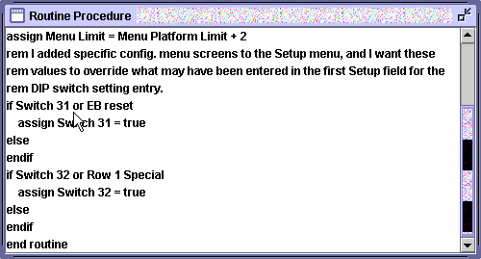
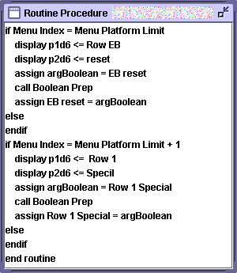
It would be more useful to the operators of the game to know what was being set here, and it may be interesting to enable other optional settings that the programmer has in mind through the Game Setup menu. For this reason, it is possible to allow the user to modify the hardware test routines in the Game Setup menu to add entries as required. Below is shown first; the logic provided in the game Power Up Hook routine necessary to set up the ability to add menu entries at the end of the setup menu. In this case 2 items are to be added, as shown in the first line. Because these two entries are clarifications of the DIP switch setting options that the platform routines already provide a default entry for in the DIP switch menu entry value, the last two tests at the end of the routine show the logic used to allow the default input method to set the Switch 31 and Switch 32 variables, or to use the new menu entries to do so.
Next, to the right, is shown the logic that then has to be coded into the Game Setup Hook routine (for “Counterforce”) to enable the test menu to display to the operator what these two settings allow. They are both boolean options (hence the call to the Boolean Prep routine), and they will be displayed as lines in the player 1 and player 2 display that will read; “ROW EB RESET”, and “ROW 1 SPECIL” as line entries. This is meant to mirror the switch 31 (EB reset) setting that enables / disables the reset at the extra ball target of the extra ball lamp once the Counterforce assault has descended all the way to the end of the descent lamps. The other entry mirrors the switch 32 setting (Row 1 Special) that grants both a special, and lights the special lamp under the special rollover for the game. Each of these two variables has to be defined in the variables menu prior to coding use, and they must be specified as NVRAM variables in order to be saved across a power-down.

Acting on the First or “Next” Switch to be Struck
There are two areas where the game programmer may want to act upon a condition where he / she knows whether or not the ball has hit a scoring game component or not. The first is upon ball launch, where, once the ball is put into the launch trough, if the ball doesn’t touch anything before it somehow winds up back in the outhole (for example, a weak kick-out), the game should re-launch the ball back into the trough without incrementing the ball number or going on to the next player. The second is when the game logic enables some feature on the playfield that the player has to hit prior to hitting any other target in order to collect that feature.
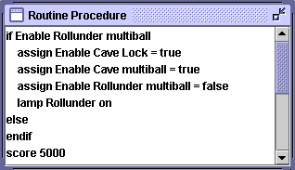
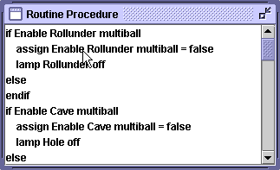
In the first case, the platform maintains a variable called Ball is in Play that can inform the programmer whether the ball has struck anything or not. In the second case, however, the programming is a little more reliant on the game coder. Let’s take the example of “Devil’s Dare”, where the right return outlane lights the rollunder lamp in the middle of the playfield that enables the “cave” lock if the player can hit the rollover before any other target. In this case, the variable that is set as soon as the ball registers on the outlane is Enable Rollunder multiball. In the coding snippet above to the right, we see part of the code that runs when the ball registers on the rollunder. If the variable is “true” then the rollunder grants the feature, and enables the cave lock on the second line. Notice the last line of the snippet that scores 5000 points. It is important that the test for this variable be done prior to any scoring, because of the logic in the Scoring Hook routine that is executed each time the player scores any points – part of the coding shown here on the left. Here, the first lines of code that run disables the Enable Rollunder multiball variable, as well as the playfield lamp. This code is run for every target struck that scores points, so if the rollunder is not the first target hit, the variable will always be false.
In short, the player should set a variable on the switch that enables a special feature, and reset it somewhere in the Scoring Hook routine. That variable can then be checked at the spot where the feature is available to grant the option.

Programming Components
Up until this point, this document has reviewed what resources are available to the programmer via the platform and hardware API’s (existing programming routines), and how to address the initial phases of coding a game. The last part of the reference manual that needs to be addressed is what variables are pre-defined in the environment, and what their function is for use in coding the games.

Platform Variables
The platform variables that a coder might need are variables that every game will probably need to use, such as the name of the game, how many balls are in the game, etc.. This section will describe each of the variables available for use in the environment. While platform variable names cannot be changed in game coding, the values can be set at any API layer, including game coding.
The NVRAM variables are those values normally set, and controlled by the game setup routines that are part of the test functionality of the game. Appendix E tabulates all of the platform NVRAM variables used.
The power-up variables are usually the kind of variables that contain scratch variables, as well as those variables that are relatively static, i.e. get initialized at game start, and never change, or variables that are not affected by game play. Appendix F tabulates all of the platform power-up variables.
The variables that are reset to their initial values at the start of each game are tabulated in Appendix H. And lastly, the variables reset at the start of each ball; in Appendix I.

Building the Executable
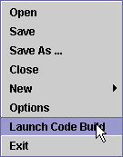
Once a game has been coded up to the point of compiling the code for download to the board, the steps necessary to build the binary code begin by sending the XML file to the Ni-Wumpf server for cross-compilation of the IDE code. This step is accomplished by selecting the “Launch Code Build” from the main menu. The development client must be online for this step in order to perform the file transfer. Please note, that the transfer can take 10 seconds or so to transfer when using a high-speed Internet connection (the file can be around 1MB in size). Once the transfer is complete, the menu will disappear, and status bar will indicate:. However, if there is a problem with the Ni-Wumpf server, or with the client’s Internet connection, the status bar will report back an error such as: . In this case, the user is advised to confirm their Internet connection for operation, and to subsequently contact Ni-Wumpf directly for assistance.

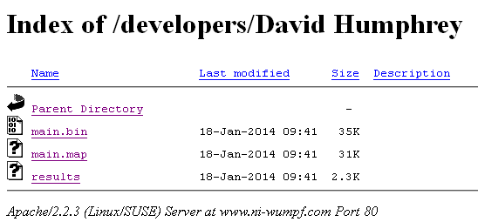
At the time of the writing of this manual, the download process is relatively manual, in that the developer needs to open up a browser window to retrieve the code. Each developer has a separate web page to get their code from. I.e. the page will be located at; www.ni-wumpf.com//developers/<programmer name>. There will be three files at this location; the “main.bin” file, which is the binary code image to be used to program the board; the “main.map” file, which is the memory map of the image, and the “results” file which is a diagnostic listing of any warnings or errors with the build.

Troubleshooting the Build
There are only a few ways in which the programmer can develop code that is not compilable in the development environment, and these are listed here:
- The programmer copied sections from one game to another. In so doing, the subroutines, variables, labels, and timers that the section referred to from the original game code were not copied into the destination program. Therefore, the copied routine refers to objects that have not yet been defined in this program.
- The programmer deleting variables, labels, routines, timers, etc. in the program w/out deleting the programming that once referenced them.
When a compile error occurs, the “main.bin” file expected on the download page will be missing (as well as the .map file), indicating that the cross-compiler could not link up the program file. When this happens, there will be only one file on the website that will help troubleshoot what has gone wrong, and it will be the “results” file that lists the compilation error. Below is a listing of the typical output showing the error in compilation when the “Motor Stop” variable is deleted from the game variable table.
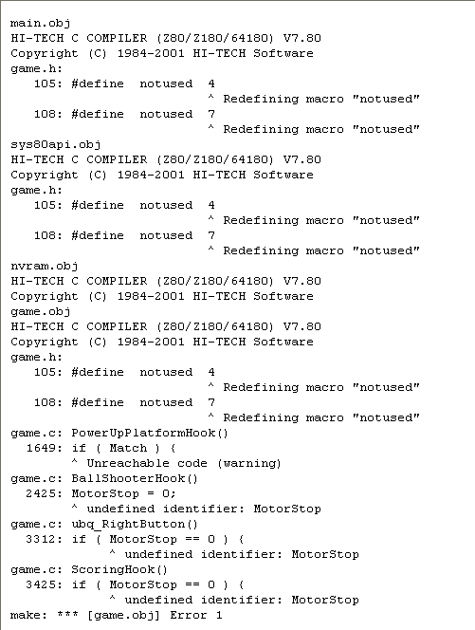
All variables have the space characters stripped from them, and any special characters replaced with an ‘_’ character before the code is compiled. So above, the error associated with inadvertently deleting the Motor Stop variable was; “undefined identifier: MotorStop”. Similar errors to this one will be reported for other objects missing from the game design.

Using the main.map File on the Download Page
Debugging the game live – Oh! Joy! Yes you can! With the memory map file (“main.map”), and the computer console hooked up to the CPU board, you can actually examine memory values while the program is running to try to figure out what the associated variable is doing during a live game. Here is an example of what this means; let’s say you were troubleshooting Volcano, and wanted to understand how the game came to “loose” a ball during multiball play. The logic seems good, in that the game monitors how many balls are in the under-playfield chute by using the Balls in Chute variable but the game stops playing after a sudden influx of balls into the “volcano”; you suspect that the game did not detect a ball dropping in the chute, and want to know what it thinks are the number of balls in the chute. Using the “main.map” file listing of the code you downloaded and programmed into the CPU, you can do this. Search the file for the variable entry required, in this case, the variable will be transcribed from “Balls in Chute” to “_BallsinChute”, and here is a snippet of the listing of this file for the variable:
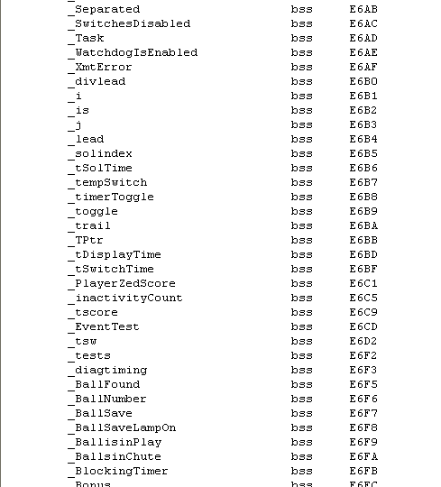
As can be seen, this variable is located in memory at location “E6FA”, but you, the programmer have to know how the variable is stored there, i.e. is this a “short” variable that takes up one byte, or a long one that may take up 4 bytes? Looking at the map file, or the IDE entry for the variable, you can quickly find out that this variable is only 1 byte long. So, while the game is running, and showing the problem, you enter in:’E’,”E6FA” (or “EE6FA”) and return. The game will come back with the hexadecimal value of the variable at this location: in this case, a ‘0’, meaning that the game does indeed think that there are no balls in the chute (even though there is one!) This is a great way to determine how the game screws up your logic.
However, how do you examine long, or integer variables, or even strings? Beginning with the numbers, it should be explained that the Z80 is a “big-endian” CPU that stores multi-byte data in memory locations that put the most-significant part of the integer; the high-order byte, at the first byte of the memory location. So, for example from above, if you wanted to look at the value for Player Zed Score you would have to examine locations E6C1 through E6C4. In so doing, you may find that these location contain the values; “00”, “E2”, “04”, and “00”, or, after re-arranging the bytes; 0004E200. As a decimal value, this turns out to be; 320,000, or the high score to date! Two byte integers follow the same logic as this, only using two bytes instead of four.
Strings are a bit different. The values are stored in hexadecimal ASCII notation, in the same order in memory as the string spells out on paper. So, to look at the state of the game (the string variable stored in Game State), the user would start dumping out the values of memory from “E7D3”, until the value of “0A” (the termination character) is reached.

Appendix A – Hardware API Hook Routines

- Game Idle Hook – used to define the minimum operation of the attract mode for the set of platforms being developed. It should be noted here, that this routine is executed continuously during the time that the game is powered-up and not being played, as well as in between balls / players while the ball is not in play. Therefore the routine should check the game state variable to determine whether it is in the middle of a game or in between balls. Typically, in game idle mode, when the game is not being played, the system will alternate between showing the high score to date in the player displays, and showing the final player’s scores from the last game. However, between balls, the routine is simply to flash the current player’s score in the display. It should be noted that this routine does not include the playfield animation routine if one is to be used – that is a game layer development process.
- Power Up Platform Hook – the routine that sets up the game once it has been powered-up. Typically this would include blanking the displays, dousing all playfield lamps, and turning on the game over lamp. In the case of the Gottlieb series, this would also include initializing the optional G-Sound board as well.
- Score Value Hook – the routine that handles all player scoring. First it calls First switch detected to set/clear any conditions that pertain to notifying the game that the ball has left the outlane and is now in play. Then, if the game is not in tilt mode, it calls the platform specific Scoring Hook to handle any platform oddities (normally empty), sets the Game State to “Game Playing”, and does the actual scoring of the value passed to it in argLong by placing this value in argLong1 and calling Score Player (back in the platform layer of code).

Appendix B – Platform API Routines

- Clear Switches API – This routine quickly flushes the input queue of all pending switch inputs at the time of the call. A good example of its use would be when the ball settles into the outhole, or a cup – because this tends to generate more than one switch closure as the pinball settles into place. The system will act on the first switch entry, but the rest of the switches need to be removed as invalid. Please note: avoid using this routine when programming multi-ball games! It is very possible to have this in a routine activated by one ball that will accidentally delete a switch struck by another ball! Instead, use the Purge Switch API routine to eliminate only specific switches from the switch queue - assigning the value of the cup switch number to the switchno variable before calling the routine.
- Display String API – Used to display character values on the displays, this routine will print out the contents of a string left justified on the displays output from the position specified in the first argument of the routine.
- Display Value API2 – This routine displays numeric values of a short, integer, or long value on the displays right justified from the position calling argument. The first argument of the routine is the least significant digit of the whole number.
- Douse Lamps API– This routine takes no arguments and acts to turn off all of the playfield lamps on the game. Because the system 80 games utilize lamp controlled solenoids, the lamp0mask – lamp4mask variables are used to mask off those lamps that are not to be affected by this call.
- Get Entry API – A routine that returns a value in the Entry Status variable. This routine is normally used to return switch input from the front door during game test and setup. A ‘1’ value returned means the operator pressed the “game start” button indicating “enter” or execute. A ‘2’ value returned means the operator pressed a combination of both the “game start” button and the “test” button, meant to clear the value or abort or sequence. A ‘3’ value returned means that the operator pressed the “test” button meaning skip, or next test. A ‘0’ means that no key entry was made within 500 milliseconds of a call to this routine.
- Get REntry API – processes exactly like the “Get Entry API”, but returns the value immediately w/out waiting the 500 milliseconds for input. This is normally used to determine if buttons are being held down for an extended period during entry which should indicate repeated entry by holding the button down.
- Get Switch Matrix API – used to read the status of the entire switch matrix into memory for subsequent queries regarding what switches are currently open/closed (via the Switch Check Thread API routine) at the time of the call. This routine helps to greatly reduce the possibility of game crashes that can result when the programmer repeatedly makes calls to the Switch Check API (see below). When the switch matrix is read into the Z80 CPU from the PIC controller, the system uses DMA transfers without handshakes. During normal operation of a game, switch interrupts from the playfield will be delayed until the entire matrix is transferred. Once the transfer is complete, handshaked I/O is re-established. Repeated calls to get the switch matrix through the Switch Check API routine will stress the PIC I/O buffers, and should be avoided.
- LightLamps API – turns on all of the playfield lamps (except those associated with solenoid logic – these lamps are masked out of operation by the Lamp0Mask – Lamp4Mask variables). Care should be taken with this routine because not all games follow the restriction of confining lamp controlled solenoids to the first 20 lamps!
- Purge Switch API – clear the switch Q of all subsequent switches that may be currently available for processing. This routine takes one argument; the switchno variable that should contain the value of the switch number to remove from the queue
- Save NVRAM API – save off all RAM variables that are destined for storage in NVRAM. Normally, NVRAM variables are committed to FLASH memory only after each game ends. However, during setup of game operation, or specific conditions in game play, it may make sense to save it immediately.
- Switch Available API – takes no arguments, but returns the value true or false in the argBoolean variable whenever a switch is currently available in the switch queue for processing.
- Switch Check API – queries the PIC, and examines the returned switch matrix for the state of the switch number in the switchno variable (open or closed). This routine operates in the same exact fashion as if the Get Switch Matrix API and the Switch Check Thread API were called separately. However, for routines that make decisions on the state of multiple switch closures, this routine should not be used, and in it’s place a single call to the Get Switch Matrix API with multiple calls to the Switch Check Thread API routine should be used instead. This routine returns the value true or false in the argBoolean variable depending on whether the switch is closed at the time of the call.
- Switch Check Thread API – Only to be used in conjunction with the Get Switch Matrix API routine to determine the state of a specific switch. The numeric value of the switch to examine is put into the switchno variable prior to calling this routine, and the value of argBoolean on exit determines if that switch is currently closed (true) or open (false).
- Timing API – Causes processing to suspend for the number of milliseconds specified in the “Lag Time” variable. This process is non-interruptible, events are processed normally, but are not serviced until the timer has elapsed. An analogy to this routine is a pause routine.

Appendix C – Platform Hook Routines

- Animation Hook – This routine is controlled by the platform environment to start at power-up, continue until game start, and restart after a game has ended. The animation routine is the attract mode sequence that the game executes during idle time to attract attention. It normally consists of flashing the playfield lamps in a pre-described way, but can include random sounds, and coordinated solenoid activity. Because each game is different this routine is programmed at the game level. However, many System 80 games share a very similar animation routine of simply cycling through the lamps in increasing lamp order.
- Ball Launch Hook – There are two routines designed to execute upon the start of a new ball, and one normally calls the other. The first; the ball launch routine, is called by the Outhole routine to set-up the playfield conditions for the player by loading any saved features/settings that are consistent across balls, to start any timers, and to then get the ball into the ball shooter lane by calling the Ball Shooter Hook.
- Ball Shooter Hook – This routine simply gets the ball into the shooter lane - it is called each time the ball is to be ejected from the outhole and again if the ball fails to reach the lane, or if it manages to re-enter the outhole w/out registering any targets.
- Cleanup Hook – The Cleanup routine is the last routine called at the end of the game. All game timers should be cancelled here, background sounds shut down, and any variable reset that need to be cleared.
- Game Specific Idle Hook - The Animation Hook routine normally handles playfield animation on a specific time interval, while the platform game idle routine is repeatedly executed in a continuous loop. The difference between these two approaches is obviously the timing with which each routine executes. This routine is called as part of the platform idle routine to be executed continuously as the game idles w/out waiting on the animation timer, should the need arise.
- Game Start Hook – Like all hooks, this routine is called once from the platform level at the time when the replay button is pressed. Any game specific initialization can be done here, such as initializing game-wide variables, flashing a fancy light sequence, performing a ball search, etc..
- Outhole Routine Hook – This routine is a very commonly used routine to handle multi-ball games.
- Power Up Hook – Used to initialize the game specific configuration once at power-up.

Appendix D – Gottlieb System 80 Platform Routines

This first section of routines comprise subroutines that are not normally used by game programmers, and would be called by upper level platform functionality:
- Add Credit – This routine performs the simple operation of updating the credits and credit display with one additional credit according to the option settings Maximum Credits and Display Remaining Credits.
- Argument Prep – A routine used in variable update during setup of game parameters for numeric values. (see also; Boolean Prep)
- Advance Replay Value – Similar to the Add Credit routine but associated with awarding a special to the player during game play, normally this routine is only called by the Award Special routine once it is determined that this is allowed.
- Award HSTD – Calls Advance Replay Value, if allowed by game options.
- Ball Save Animation – This routine is called by the Ball Save Flasher timer. Normally it executes every 1/3 second, and acts to flash the shoot again lamp for a period of time determined by the Ball Save Time setup variable. The timer is started by the Check for Ball Save routine executed by the Outhole routine.
- Bookkeeping3 – This routine provides game statistics under the setup menu for the game when accessing the bookkeeping menu. Normally, it only allows the statistic value being displayed to be reset to ‘0’. It is a subroutine used by the self-test portion of the platform software.
- Boolean Prep – Like the Argument Prep routine above, this routine is used to initialize field entries for variable update during setup of game parameters.
- Center Coin Chute – Each coin chute has the capability of registering different credits for the amount of money inserted. Please refer to the game manual for details on the various coin / credit combinations for each possible value of this menu item. This routine controls setup and crediting during coin entry.
- Check for Ball Save – Ball save is the logic that governs whether the player is given an initial grace period immediately following ball launch during which the ball can drain and then be re-served w/out loss of the player’s turn. The value that is saved in NVRAM for Ball Save Time is used to time the period during which the ball will be re-served. This routine controls flashing the EB lamp during the ball save period, and is controlled by the Score Value Hook to determine when the timer should start counting down.
- Check HSTD – Normally as points are scored, the game keeps track of whether a threshold has been passed, or when the player has achieved a new high score to date. This routine controls what happens as the player registers a new high score according to the settings of 4 HSTD, Allow HSTD, and the award settings. It is called once at the end of game play to check all players scoring values to the high score to date. Note, that a tilt may disqualify a player (or players) from qualifying for a position.
- Check Match – Also called once at the end of the game to check the last two digits of a players score against the random match value shown in the match display. This routine is enabled by the Allow Match variable.
- Check Thresholds – Each time a player scores any value, this routine is called to determine if his score has exceeded one of three possible threshold values.
- Coin Count – Called by one of the three possible coin slot routines, this routine calculates credits to be granted based on values passed to it in the argint and argLong variables.
- Game Setup – This routine is called via the game test routine once the front door self-test button is pressed. It’s operation is more fully documented in the platform manual where it describes the variables that can be modified in this routine. In general, these variables pertain to game operations such as scoring thresholds, high score to date, game mode, etc..
- Game Test – This is the main routine entered into whenever the operator presses the game’s self-test button. It handles navigation through each of the submenu’s for option settings, game settings, statistics, tests, etc..
- Get Threshold Count – A subroutine to return back to the calling routine the next possible threshold that the player qualifies to beat.
- Initialize ball variables – This routine is created dynamically by the compiler based on the variable definition at time of variable creation. Just prior to the platform calling the ball launch routine, this routine is called to initialize those variables dependent strictly on what they should be set to at the beginning of each ball.
- Initialize Coins – Called on power-up this routine sets the variable necessary to correctly assign credits based on the coins deposited thus far. This can be important in the event that a single coin unit can result in a fractional credit value (3 coins / 2 games). This status of how many coins were deposited toward game credit, is maintained through-out the game up-time, such that, if two out of three coins were deposited, a game played, and then the third coin deposited, the game would know how to correctly award credit on that third coin.
- Initialize game variables – This routine is also created dynamically by the compiler to initialize variables that are strictly game dependent (such as the current ball number). It is called once at the time when the game start button is pressed.
- Initialize NVRAM Variables – This routine is created dynamically by the compiler to initialize NVRAM variables only at the time that the operator requests a return-to-factory default initialization from the game test menu.
- Initialize system variables – This routine is also created dynamically by the compiler to initialize variables that need to be set only once at power-up.
- Left Coin Chute - Each coin chute has the capability of registering different credits for the amount of money inserted. Please refer to the game manual for details on the various coin / credit combinations for each possible value of this menu item. This routine controls setup and crediting during coin entry. (see Right Coin Chute overview below)
- Option Settings – This routine is part of the game test routines that control option parameters pertaining to operation of any pinball games, such as what coins award what credits, the number of balls for each game, etc. It’s operation is more fully documented in the platform manual where it describes the variables that can be modified in this routine.
- Outhole – The outhole routine accomplishes a lot of the overhead pertaining to game play, from updating the player number that is up and decreasing the ball number, to handling what happens if the player has tilted during his ball. In general, the outhole routine handles the following operations;
  - Clearing up any tilt conditions on the game
  - Calling the game specific Outhole Routine Hook, which allows for the programmer to insert game specific code that should execute immediately after the ball drains into the outhole and even just before any bonus is scored.
  - Calling the game specific Score Bonus Hook, to execute the programmer specific routine to score the game bonus (including lighting bonus lights and scoring multipliers, etc.)
  - Clears the Ball is in Play variable.
  - Increments the ball in play value (Ball Number), the current player value (Player Number), or decrements the player’s available extra balls and determines if the last ball of the game has just been played.
  - If the last ball is over, it sets the Game State variable to “Game Over” and then performs the following routines:
    - If Match is enabled; performs the match evaluation and display.
    - Checks to see if any of the players have exceeded any of the high scores (Check HSTD) however configured.
    - Updates NVRAM with current game statistics.
  - If this is not the last ball, the ball variables are initialized with a call to Initialize Ball variables.
  - The second of two game specific hooks, Ball Launch Hook is called to initialize game specific functions and get the ball into the shooter lane.
  - Lastly, if there is a ball save feature enabled it is initialized.
At the end of the outhole routine, if the game is afoot, the current player score should be flashing, the correct ball number has been updated, all variables should be initialized, and the game should be ready to continue. Conversely, the game should be in game over mode!
- Platform Revision Log – Changes made to the platform coding base are recorded as remarks in this documentation routine.
- Replay Button –The routine that starts it all – the replay button calls a number of routines to initialize the game for play, but also makes some logic decisions. If the game has available credits, and is currently in game over mode, it performs the actions listed below to start up a game. However, there is one caveat to note at this time as well. If a game has been started, and it is still during the first ball (of any player), when the replay button is pressed, it will increment the player count, thereby adding a player to the game. Starting a game consists of:
  - Confirming that the correct number of balls are available to start the game, and if not, initiate a ball recovery routine to get the balls in the position expected to start the game. An example here would be to find a ball stuck in a kicker hole at the end of an abnormally terminated game, and to get it into the outhole.
  - The game idle routines are all halted.
  - If the last ball is over, it sets the Game State variable to “Game Started”.
  - Resets any tilt conditions, and releases the game over solenoid, the playfield lamps are all doused, and resets all possible player threshold values.
  - The Ball Launch Hook is called to put the ball in the shooter trough.
  - The player scores are all reset, and bookkeeping is updated in NVRAM.
  - Lastly, the platform routine calls the games specific Replay Hook routine to perform any game specific code required at game start.
- Right Coin Chute - each coin chute has the capability of registering different credits for the amount of money inserted. Please refer to the game manual for details on the various coin / credit combinations for each possible value of this menu item. This routine controls setup and crediting during coin entry, updating the Coin Counter – Slot 2 NVRAM variable (keeping track of how many coins went through the second coin chute). The More Coins 1, More coins 2 and Coin Chute Control variables keep track of partial coin credits for each coin chute in the event that one chute has a different coin acceptor from the other.
- Score Player – this routine handles all of the logic that is involved with updating a player’s score on the game, from getting the right player’s score display updated, to incrementing the player’s score value, deciding what to display if the game is currently showing a tilt warning, and finally to check whether the player has exceeded any threshold values that would justify an award. The value to be added to the score is first stored in the ArgLong1 variable, and then this routine is called.
- Scroll displays – the System 1 and System 80 games from Gottlieb; MPU-35 games from Bally; and anything earlier than a System 7 game from Williams, all share a slight design constraint from modern day games – 6-digit displays. On most of these systems, this constraint is irrelevant – you just can’t roll these games over. However, on many of these games, you’ll find some impromptu high-score game values carved right into the head of a game to make note of a truly memorable game, when it was found that the game itself just had no way to store and display this information for the user. It is for this reason that we included the capacity for these games to maintain scores well into the seven digits (< 10 million point games). However displaying that score is a challenge, and it has been implemented through this routine, coupled with two platform timer routines (scroll timer, and scroll timer last) that asynchronously calls this routine every 220 milliseconds.
Basically, the player’s seven-digit score is scrolled across the six-digit displays from right to left every three seconds, so that, while most of the time, the least significant six-digits of the score are displayed, it is very apparent that the player has rolled the game over, and what the score value really is. The game variable; scroll digit maintains a counter of the position that the scrolling value currently has in the display so that the routine knows when to stabilize the scroll. The game variable, scroll displays, is maintained by the Score Player routine once any player’s score has gone into the millions. The NVRAM variable, Enable millions, is set / cleared by the front-door game setup menu to enable 7-digit scroring.
- Scroll HSTD – this routine is used during game idle to display any player’s score, and any high scores to date, whose value exceeds 1 million points. It utilizes the HSTD scroll timer to maintain asynchronous scrolling of the displays.
- Set Player Thresholds – In order to cut down on variable space used, each player has a variable dedicated to keeping track of what (if any) threshold can be crossed to achieve an award (Award Special). For example player one uses the Player 1 threshold value to maintain the goal for the next threshold to cross. If this value is ‘0’ then there is no available threshold to achieve. If not, then the award is granted, and the Threshold
Value variable is updated with the next threshold to achieve (or ‘0’, if there is none) by this routine, and the player’s corresponding threshold is updated from this variable.
- Slam – Activating the slam switch, calls this routine that basically updates the NVRAM variable for the Number of Slam Tilts to occur, turns off the Game Over relay, sets the Game State to “Game Over” and finally calls the game hook routine that handles any game – specific clean-up processing.
- Slam Hook – This routine is the stub entry for any functionality at the game level that needs to be performed in the event of a slam tilt.
- Threshold prep – a subroutine to prepare variables for use in setting up front door entry of threshold values.
- Tilt – This routine handles how the game should react to a tilt switch closure. The UBQ design allows for the game to endure multiple tilt switch closures before tilting, such that any minor tilt (less than the maximum number of tilts seen within 4 seconds) will have the game display a warning message in the displays, but keep playing. The Tilt Badness value contains the value of this number of hits that the system can handle before hard tilting (ball over). A setting of ‘1’ would put the game in the original tilt mode of the player loosing the ball, a setting of ‘0’ is the conservative mode where the whole game ends on a single tilt. Any setting above that is a count of the allowed number of tilts. Tilt calls the game layer Tilt Hook, for game specific tilt procedures.
There are two timers used to handle tilt notification, and counting. The first; Tilt restore display, clears the displays of the tilt warning string after 1.8 seconds of the tilt occurring. The second; Tilt Reset, decrements the number of tilts counted over the last 4 seconds until the count reaches ‘0’.
- Tilt Display Restore – As described above, this clears the warning message from the player 1 and player 2 display and restores the players’ scores to the displays.
- Tilt reset routine – As described above, this decrements the tilt count until it reaches ‘0’.
- Unblock Timer – Used primarily in the Game Idle routine, this subroutine just clears a blocking timer variable; Blocking Timer.
These last sections of routines are a list of those subroutines that would be used by game programmers in coding a game.
- Add-a-Ball – This routine performs the function of adding a ball to the current player (incrementing Extra Balls Earned), lighting the ‘shoot again’ lamp and updating statistics (Number of EB’s Awarded). It would be used in game programming after the player has struck the lit extra ball target.
- Award Special – Determines how a playfield special is awarded according to game options (Special Awards Replay); either by awarding an extra ball, or additional credit. Normally it would be coded as part of game programming when a player has struck the “special” target when lit. You may only be awarded a special if; both the Special (Operator Override) value is clear, and the player did not already score a special during this ball (Ball Number is not equal to Special During Ball).
If the Operator Override is set, then the value of Special Point Override is scored instead.
- Cleanup Hook – This is a routine placeholder for game code to be developed at the game programming level to address any programming needed to perform at the very end of the game.
- First switch detected – This routine is called anytime a switch has been detected on the playfield (except the outhole / tilt switches). It’s use is to set the Ball is in Play variable, and to handle the Shoot Again condition when the player has achieved an extra ball during his last ball.
And, of course the hook routines that are programmed at the game layer to handle default functions that every game in the platform will use:
- Score Bonus Hook – the routine to score the accumulated bonus / bonus multipliers.
- Scoring Hook – the routine to perform any processing that need be done whenever the game programmer is looking to do something whenever the next switch is detected for scoring.
- Tilt Hook – the routine to handle any special tilt processing in the game – like removing the ball in the lower playfield in Black Hole.
- Test Hook – this routine gives the coder a diagnostic entry point into the game being developed. Any code in this routine is executed once the ‘0’ command is entered in at the computer console linked up to the CPU. It is a great way to try out code w/out necessarily having to simulate the game conditions that would eventually execute the code here.

Appendix E – Platform NVRAM variables

- Ball Save Time – when not set to ‘0’, this variable represents the number of seconds at the start of each ball that the game will forgive the player for losing the ball, and re-serve the ball to the shooter lane. During this period the extra ball lamp will be flashing.
- Balls per Game – the number of balls in a game. This value can range from 1 to 9.
- Coin Chute Control – when set, this boolean variable causes the pricing options set for coin chute 1 to be used in controlling the pricing on coin chutes 2 and 3 as well.
- Coin Counter – Slot 1 – maintains the bookkeeping count of all coins through the left coin slot.
- Coin Counter – Slot 2 – maintains the bookkeeping count of all coins through the right coin slot.
- Coin Counter – Slot 3 – maintains the bookkeeping count of all coins through the center coin slot.
- Coins per Credit 1 – this variable contains the integer value of the pricing scheme first documented in the original Gottlieb manuals for the right coin chute. I.e. values 0 – 8 represent how many game credits are given for every coin dropped in the chute; values 9 – 13 represent how many credits are awarded for every 2 coins dropped, etc..
- Coins per Credit 2 - this variable contains the integer value of the pricing scheme first documented in the original Gottlieb manuals for the left coin chute. See above.
- Coins per Credit 3 - this variable contains the integer value of the pricing scheme first documented in the original Gottlieb manuals for the center coin chute. See above.
- Display Four Highest Scores – a boolean variable that, when set, instructs the game to use 4 high scores to date, rather than only one. Each high score is displayed in the player 1, 2, 3 and 4 display for the 1st, 2nd, 3rd, and 4th highest scores respectively. Each of the player’s score is compared to these four scores to determine their ranking amongst the four highest scores. Credit awards are given for beating the third and fourth high score (1 credit), second high score (2 credits), and the high score to date (3 credits).
- Display HSTD at idle – a boolean variable that, when enabled, will cause the game to alternate between showing the high score to date (or 4 highest scores), and the most recent player’s scores.
- Display Remaining Credits – a boolean variable, when enabled, instructs the game to display how many credits are available on the game in the credit display.
- display_refresh_rate – a long variable set via the computer console interface, containing the display refresh rate. The value ranges from 16 to 5000, and indicates, in multiple microseconds, the period of time between display digit refresh pulses. The shorter the value the faster the scan, and the brighter the display. The default value of this parameter is 3400, which results in digits on the display being pulsed about every millisecond.
- Enable millions – all games limit the maximum value of the score they can support by the width of the player’s display. The system 80 games have 6 digits in the display, while the system80A games have 7, allowing the System 80 games to score up to 1 million, and the System 80A games up to 10 million. This boolean value enables the system to display scores greater than the display width by enabling a software scrolling feature that scrolls scores of 1 million or more on a six-digit display from right to left. All high scores to date are enabled for unlimited scoring as well.
- First Award Threshold – this is the value of the first replay setting. If this value is ‘0’ there is no award for exceeding any of the scoring thresholds.
- Fourth HSTD – when the NVRAM setting for displaying the four HSTD’s, this variable is the value of the fourth HSTD. It can be set indirectly by setting the High Score to Date to an initial value via the “Setup” menu, and is then maintained by the game.
- Game Mode – normally, the program for a game will be developed in the IDE to match, as closely as possible, the play of the game as originally conceived by the game manufacturer. If the programmer has coded up options for how the game is played, or a new logic for the playfield layout, this value will select which variant of the game is to be played. The initial value of ‘0’ plays the original game, by default (Game Setup menu).
- Games Played – originally set at ‘0’, this value keeps track of how many times the game start button has been pressed.
- GSound Board – a boolean variable to indicate to the CPU when the game hardware is to include use of the “GSound” sound hardware. The CPU will handle initialization of the GSound board when enabled.
- High Score to Date – this is the value of the highest score to date scored on the machine. Once a new value is entered into the machine via the Game Setup menu, the 2nd, 3rd, and 4th high scores to date will be set to a value 20k, 40k, and 80k points below this setting respectively (unless that value is less than ‘0’).
- HSTD awards replays – a boolean variable that enables credit award at the end of the game for beating any of the high scores to date (if enabled). For beating the 3rd and 4th high score to date the player is awarded a single credit For beating the 2nd HSTD, the player is awarded two credits, and for beating the HSTD, the award is three credits.
- Idle Animation Routine – a boolean variable to enable/disable the idle animation routine.
- Match – a boolean variable to enable/disable allowing the game to calculate a random number between ‘0’ and ‘9’ to match the second digit of the player’s score (i.e. ‘10’ – ‘90’) at the end of the game. If a match occurs on any of the player’s scores, a free game is awarded.
- Maximum Credits – a variable limit that caps the amount of game credits the game will accumulate before it will ignore any more added game credits (whether by coin, or scoring). If this value is set to ‘0’, the game will enter into free-play mode, where no credits are required to start the game.
- Maximum EB’s Allowed per Ball – during game play, this value limits the amount of free balls that a player is allowed to accumulate. It does not, however, change game play in such a fashion as to disable lighting of the Extra Ball target lamps – the game will just ignore the award.
- Number of Credits – this is the value of the number of credits remaining on the game.
- Number of EB’s Awarded – a bookkeeping value to keep track of the overall number of extra balls awarded during game play since the bookkeeping was last zeroed.
- Number of Slam Tilts – a bookkeeping value to keep track of the overall number of slam tilts the machine has suffered since the bookkeeping was last zeroed.
- Number of Specials Awarded – a bookkeeping value to keep track of the overall number of specials awarded during game play since the bookkeeping was last zeroed.
- Number of Tilts – a bookkeeping value to keep track of the overall number of regular tilts the machine has suffered since the bookkeeping was last zeroed.
- Platform Revision – an alphanumeric value of the revision (i.e. “2.23”) of platform code currently being used. Each update to the platform code should result in an entry in the Platform Revision Log, and an increment in the value of this field.
- Play Sounds - a boolean variable to enable/disable the game to play sounds during game play (not used).
- Scoring Sounds – a boolean variable to enable/disable the game to play sounds during scoring only (not used).
- Second Award Threshold – this is the value of the second replay setting. If this value is ‘0’ there is no award for exceeding this or any of the subsequent scoring thresholds.
- Second HSTD – when the NVRAM setting for displaying the four HSTD’s, this variable is the value of the second HSTD. It can be set indirectly by setting the High Score to Date to an initial value via the “Setup” menu, and is then maintained by the game.
- solenoid_pulse_width – the value pulse width of the solenoid activation signal. The amount of time that the solenoid is activated will change the amount of power that it delivers. Each game platform may be different. The System 80 solenoids nominally are energized for 190 mSec.s, valid values are in the range of 1 to 250.
- Special (Operator Override) – a boolean variable for the operator to disable the awarding of credits awarding during a special (if enabled). The override awards “Special Point Award“ points in place of a knock.
- Special Point Award – the long value of the amount of points awarded for a special whenever the “operator override” setting is enabled. This value can be between 10K to 90K.
- switch_scan_rate – a long variable set via the computer console interface that contains the pulse width of the solenoid activation signal. This is the amount of time that the solenoid is activated and may change the amount of power that it delivers. Each game platform may use a different value. The System 80 solenoids nominally are energized for 190 (mSec.s), valid values are in the range of 1 to 250.
- Third Award Threshold – this is the value of the second replay setting. If this value is ‘0’ there is no award for exceeding this scoring thresholds.
- Third HSTD – when the NVRAM setting for displaying the four HSTD’s, this variable is the value of the third HSTD. It can be set indirectly by setting the High Score to Date to an initial value via the “Setup” menu, and is then maintained by the game.
- Tilt Badness – this is a short value representing the number of times that the tilt mechanism can signal a tilt before the game actually tilts, and puts the ball out of play. The values vary from 0 to 5, with ‘0’ actually disabling the game entirely on a tilt (i.e. game over!), and 1 through 5 representing the number of tilts detected in a 4 second period before tilting the game.

Appendix F – Platform Power-Up Variables

- argBoolean – a scratch boolean variable.
- argint – a scratch integer variable.
- argLong – a scratch long variable.
- argLong1 – yes, another scratch long variable.
- argString – a scratch string variable.
- Blocking Timer – used during idle animation, this boolean variable is continually toggled by a continuously running timer every few seconds – usually to signal the main routine to toggle between showing the high scores to date, or the last players’ score.
- Chime Lag Time – a relatively static integer variable dictating how long to hold the chimes up (not used with sound boards).
- Current Entry – a long scratch variable used in the game testing routines.
- DisplayTestMode – another variable used in game testing to toggle the display test between showing all digits on the displays at once, and showing only a single value stepping across each of the display digits in sequence.
- displayvalue – as described below, this variable can be used in the display routine to provide a variable value in the output, instead of a literal.
- displayvar – this variable is used to contain the location of where to begin outputting display data to, in a call to the hardware display routine, where the position entry may be a variable value. Normally, the display command works solely with arguments composed of entries in the display table, or a literal numeric value. This platform variable allows the coder to use a variable for this value. It is up to the programmer to correctly set this position information prior to the call.
- Entry Return – a long scratch variable used in the game testing routines.
- Entry Status – a short scratch variable used in the game testing routines.
- Fast Switch – normally, the hardware discards any duplicate switches in the switch queue that are detected within SwitchEliminationTime of the time it is operating on the current switch. In other words, with dirty switches, it is possible that a pinball striking a target once that more than one entry could be generated falsely (particularly when working with drop targets). By setting this value to “true” the hardware disables this processing and allows repetitive switch entries to registered. An example in the use of this would be on a spinner, where fast, repetitive switch detections of the same value would be expected. The first detection of this switch might set this value to be true, and start a timer to subsequently disable this flag in a second or so.
- Game State – this string variable describes the state that the game is currently in. Platform conditions used at this time include; Game Playing, Game Over, Game Started (before first switch of first ball is detected); and Game Tilt. This is not an efficient test mechanism however, and is likely to be replaced by numeric values in the future.
- HardwareIndex – a scratch index variable used in game testing to keep place in where in the test menu the operator is working.
- HSTD Showing – a boolean variable used in the idle animation routine to indicate whether the game is showing the high score to date, or the last players’ scores.
- Idle Hook Override – the boolean variable used to disable the game idle routine, usually between balls during a game. It’s not used much.
- Incremental Value – Used in the game setup menus as the value between button presses that is added to the Current Entry value when that setting is incremented.
- Lag Time – a scratch variable (long) used by the Timing API routine to hold the number of milliseconds the CPU will spin in a loop for before returning to game operation.
- lamp strobe 0 mask – lamp strobe 4 mask – during solenoid testing, and in all logic where the hardware must differentiate between when a lamp circuit is hooked up to a transistor for a coil, this set of bit mapped variables will specify what (if any) lamps in the lamp array (latch lines L0 through L11) are actually used as lamps. In most of the System 80 games, the designers only used the first few latch lines to map solenoids into – which is why there is only masks for lamp rows 0 through 4.
- lampvar – a scratch variable containing the number of the lamp (between 1 and 48) to be used in the “lamp” command.
- Maximum Entry Value – the maximum field entry value possible for an integer/long before the variable is wrapped to the Minimum Entry Value in the game setup procedure.
- Minimum Entry Value – the minimum field entry value possible for a field in the game setup procedure.
- More Coins 1 – a relatively persistent value that maintains how many more coins need to be dropped into the right coin chute before credit(s) are given. This variable is initialized at power-up and game setup to correspond to the pricing scheme of coins per Coins per Credit 1.
- More Coins 2 – a relatively persistent value that maintains how many more coins need to be dropped into the left coin chute before credit(s) are given. This variable is initialized at power-up and game setup to correspond to the pricing scheme of coins per Coins per Credit 2.
- More Coins 3 – same as above for the center coin chute.
- Old Sound – this is a Boolean variable that informs the hardware that it will be using the older synthesized sound board, and to hold the sound pulses up longer. Normally, this would only be used for a System 1 platform.
- Options Index – a scratch variable indicating where in any particular test menu the operator is currently editing.
- Options Limit – a scratch variable set for each test menu that indicates when the menu “rolls over” to the first entry field again.
- Player Score – a long scratch variable used to contain the current player’s score to operate on.
- RawChar – a scratch byte used to output raw segment data to the display digit.
- retval – an integer scratch variable that will normally contain the resultant value returned from a game routine that needs to return a status to the calling routine. This variable is not “protected”, and will be overwritten by each routine in a calling chain that uses it!
- Scoring Lag Time – used in the System 1 platform, this is the time to wait between successive sound requests sent to the chime unit or the sound board. If this value is too low, anything but the first chime is left unheard, because the chime plunger does not have time to recover before being sent up against the chime for the second strike.
- Search Count – used in the ball search routine, this is a scratch variable used to maintain the count of how many times the game has gone through the playfield looking for a ball locked in a hole or chute. Once this count is exceeded, the game gives up, and assuming that the correct number of balls have not been accounted for, determines that there are not enough balls in the game to continue.
- Slam Switch – this variable identifies what strobe/return switch number is used on this particular game for the slam switch. It is not going to change except by platform release, and for the System 80 games, it is switch number 8, which corresponds to strobe line 8, not used on any Gottlieb System 80, operating on return line 0. The Ni-Wumpf hardware maps the hardwired slam switch to a return on the switch matrix.
- solenoid lag time – a variable length of time that is normally used between successive calls to a solenoid command to keep the hardware from pulling the coil voltage too low.
- soundvar – a scratch variable used by the “sound” command to play a sound based on the variable contents.
- Start Requested – a boolean condition used during game start when the game has decided to go into ball search mode, as a result of not having the requisite number of balls in the ball trough. Once the search has ended successfully (with all the balls accounted for), this variable, when set will subsequently cause a game to begin.
- Switch Elimination Time – as described above, this is the time value between switch entries that the system will look for duplicate switches. Nominally, this is set to 80 milliseconds, realistically, this is added in to normal OS processing, and is more likely to wind up being 80 + 120milliseconds.
- switchno – a variable passed to and from subroutines to indicate what switch to act upon when searching/modifying the switch queue, or examining the switch matrix for closed switches.
- TestExit – a variable used in the self-test routines, updated to notify the main routine to exit the test sequence.
- TestIndex – a variable used in the self-test routine to keep track of which self-test the operator is currently working in.
- TestTime – an idle counter used in the test routine that will cause an automatic exit out of self test once this value reaches 0. It is reset to a set value each time any entry is sensed at the self-test/start buttons.
- Threshold Value – a temporary storage variable used by various threshold routines to maintain the current threshold value yet to be achieved.

Appendix G – Platform Game Variables

- Ball is in Play – this is a boolean variable used in various routines to determine if the ball has logically entered play yet. A ball put into the shooter lane is not yet “in play” between game balls until it has struck some object to score points from.
- Ball Number – the current ball number – always less than the balls per game variable.
- Extra Balls Earned – a count of how many balls have been awarded to the current player during the game.
- Match Value – the match value is the random number generated at the end of a game (when enabled) between 00 and 90 (ten’s values). If, at that time, any player has a score ending with the last two numbers being the same as the match value, the player is awarded a free game.
- Number of Players – the integer value of how many players are currently playing between 1 and 4, (or 6 on some Bally games).
- Player 1 Score – the long value of the first player’s score.
- Player 1 threshold no. – Not used.
- Player 1 threshold value – the long value of the next threshold value that player 1 needs to exceed to score an award. This value starts out at the beginning of the game, with the first threshold value for the game, or ‘0’ if no thresholds are specified. Upon successful achievement of the threshold score, this value will increment to the next threshold, or ‘0’ if there is no threshold left for the player to achieve. A value of ‘0’ means that there is no score for player 1 to beat.
- Player 2 Score – the value of second player’s score
- Player 2 threshold no. – Not used.
- Player 2 threshold value – (see above note on the player 1 threshold value)
- Player 3 Score – the value of the third player’s score
- Player 3 threshold no. – Not used.
- Player 3 threshold value – (see above note on the player 1 threshold value)
- Player 4 Score – the value of the fourth player’s score
- Player 4 threshold no. – Not used.
- Player 4 threshold value – (see above note on the player 1 threshold value)
- Player Number – the current player number (between 1 and 4).
- scroll digit – used in the routines to display a rolling score across the players display, this long value defines where the score is going to wind up displaying. A value of ‘1’ means that only the first (most significant) digit is going to be seen in the rightmost digit of the display. A value of ‘10’ means two digits are shown, etc. until the maximum player score value (on a 6-digit display – 1000000).
- scroll displays – a boolean value indicating that the game is set up for scrolling display of values too large for the physical display hardware to display.
- Shoot Again – a boolean value indicating that the current player has been awarded an extra ball, and will be allowed to shoot this ball again before the next player’s turn.

Appendix H – Platform Ball Variables

- Ball Save – a boolean variable indicating that the game is operating within the time period where the “ball saver” feature is active. During this time, if the ball is lost in the outhole, it will be re-served to the playfield.
- Ball Save Lamp On – a boolean variable used in the game flashing routine to track whether the “Same Player Shoots Again” lamp is on or not. If it’s on, turn it off and vice versa.
- Ball Save Total – a scratch variable counting down from the number of seconds (times 3) that the ball save feature is to remain active during the time that the ball is in play.
- Bonus Multiplier – the end of ball bonus multiplier variable.
- Player Bonus – the total bonus units achieved during the current ball in play for the current player.
- Playfield Multiplier – there are some games that will enact a scoring multiplier for any scoring done during the period that a playfield multiplier is active. This is the variable containing the value of that multiplier, from 2x on out.
- Re-Serve Ball – Not used.
- Special during Ball – a short variable tracking the ball number that any special was last awarded during the ball in play. If this value is the same as the current ball in play, then a special has been awarded during this ball’s play.
- Special Scored – Not used.
- Starting Bonus Value – Not used. Some games start with ‘0’ bonus scored at the launch of a new ball, many start with ‘1’ (or 1000 pt.s). The game initialization sequence will, be default, set the Player Bonus to ‘0’ on a new ball. This variable can be used by the game programmer to override this default setting.
- Tilt Warning Showing – this boolean variable is used to pass on to the programmer the state of the player displays, in the event that a tilt warning has just been issued, and is still showing on the displays. By default, if the variable is set to true, the platform will not update the player’s score values, which would garble the display output.
- Tilt Warnings – a short variable tracking how many plumb bob / tilt mechanism events have been detected in the last 4 seconds. Once this value exceeds the Tilt Badness setting, the game goes into tilt mode.
- Tilted – a boolean variable tracking whether the game is in tilt mode.

Currently the software has been tested to run with Internet Explorer.
Keyboard shortcut - <shift><ins>.
A “Cut” is just the combination of copying the section of highlighted lines into the clipboard, and subsequently deleting them (keyboard shortcut - <shift><del>). The clipboard content is still available for subsequent pasting.
Note: this routine is normally not used during game programming.
Note: this routine is normally not used during game programming..

